Worship Calendar

Sunday, May 3, Easter 5, 10:30 a.m. (White) Holy Eucharist followed by a Retirement Tea in the Parish Hall AG Team 1 (EA- Gail Trewhitt)
Acts 7: 55-60 (Shirley Butt) Psalm 31: 1-5,15-16 1 Peter 2:2-10 (Sandra Squires)
John 14: 1-14

Sunday, May 10, Mothers’ Day With Coastal Sounds Community Choir, 10:30 a.m. (White) Holy Eucharist (AG Team 2) (EA Donald Sparkes)
Acts 17: 22-31 (Donna Dawe) Psalm 66: 7-18 1 Peter 3: 13-22 (Robert Dawe) John 14: 15-21

Sunday, May 17, Ascension Sunday, 10:30 a.m. (White) Holy Eucharist

Sunday, May 24, Day of Pentecost, 10:30 a.m. (Red) Morning Prayer

Sunday, May 31, Trinity Sunday, 10:30 a.m. (White) Holy Eucharist

A Note from the Treasurer: Please ensure your envelope number is on all financial correspondence so that we can credit your account for income tax purposes.

Sunday Bulletins - If you’d like to give a weekly bulletin to commemorate the life of a loved one or in Thanksgiving for an event in your life, please contact David in the office for the dates available.

Service Roster: Sidespersons Sound Room
May 3rd Audrey M. Andrew B.
May 10th Betty P. Bob D
May 17th Betty H. Ken L..

Bishop: The Right Reverend Dr. Samuel Rose
Diocesan Administrator: The Venerable Charlene Taylor
Rector: The Reverend Canon Josiah “Jotie” Noel, T.S.S.F. (Third Order, Society of St. Francis)
Parish Deacon: The Reverend Lisa Cox
Organists/Choir Director: Stephanie Gavell, Amanda Dawe-Ledwell
Parish Wardens: Sharon Smith & Audrey Mercer
Office Administrator: David Kelland

Welcome to the
Parish of St. John The Evangelist
Conception Bay South, Newfoundland
May 3, 2026
Fifth Sunday of Easter



This Bulletin is given to the Glory of God
and in Loving Memory of
Nora Hutchings
by Sharon, Jim and Family

www.stjohntheevangelistnl.com
Facebook: SJTE Topsail
Office email: sjtetopsail@nfld.net
Office phone number: 709 834-2336
Rector Email: jotienoel@gmail.com
Cell: 709 325-2366

Our Parish Mission Statement
We believe in nurturing a community of faith dedicated to inclusion, support and sharing the story of God's love with all people regardless of the stage of their spiritual journey
The Parish live-streams our regular Sunday Services and posts to Facebook
Jesus said, “I am the way, the truth, and the life, says the Lord; no one comes to the Father, but by me.” John 14.6

A warm welcome to you this morning as our faith community gathers with gratitude and joy to celebrate Holy Eucharist. A special welcome to those who may be visiting and to those who have returned after a period of absence.

This week our Bible lessons:

Acts 7: 55-60 One of the most dramatic scenes in Acts reveals the martyrdom of Stephen, who full of the Holy Spirit, proclaimed the ascension of Jesus at God’s right hand. He died praying that God would not hold this sin against those who stoned him, ‘And Saul approved of their killing him.’

Psalm 31: 1 – 5, 15 – 16 The psalmist expresses trust in God amid distress and enemies.

1 Peter 2: 2 – 10 An early Christian congregation is told, “You are a chosen race, a royal priesthood, a holy nation, God’s own people, in order that you may proclaim the mighty acts of him who called you out of darkness into his marvelous light.”

John 14: 1- 14 Jesus has announced he is leaving the disciples, but he reassures them that even in his absence disciples will continue the work he has begun in them. He makes three promises:
First, abiding place with God; his departure will not sever their relationship with Jesus but will deepen that relationship.
Second, that disciples will have a sure way to God.
Third, for power to not only sustain believers but also to do even greater works than Jesus did (v. 12). (In next Sunday’s Gospel we will hear a promise of the Holy Spirit in verses 15-21.)

Lord Jesus, you have promised us that:
whatever we attempt in your name we will be able to do;
and whatever we ask in your name shall be accomplished by your name.
We pray this in your name, Lord;
keep us acting and praying in your name
so that your promise might be graciously fulfilled in us. Amen. (ACC)

We invite prayers for those who are sick: Colin C., Isla, Phyllis H., Dave M., Erica H., Diane W., Una D., Ann H., Dave Y., Emily O., Don M.

New Priest in Charge, St. John the Evangelist – Bishop Rose has announced the appointment of Venerable Edward Keeping as our new Priest in Charge beginning June 1. We look forward to welcoming Archdeacon Ed and his wife, Joyce, to our parish.

Pastoral Emergencies / Need to Speak to Canon Jotie –
1. In the event of a pastoral emergency do not hesitate to contact Rev. Jotie directly. He has the same cel number and will attempt to answer and respond to calls on an ‘as needed’ basis.
2. If you need to speak to Rev. Jotie, we suggest you start contacting the Parish Office (Monday – Thursday, 9 – 1 p.m.). As needs unfold his regular intended work schedule of Wednesday and Saturday may be changed.
3. Canon Jotie is ready, willing, and able to visit you in your home for conversation, prayers and/or Home Communion.

Bible Study – We chat about the Sunday Bible Lessons upstairs in Church on Thursdays, 11:00 a.m. Our facilitator, Gail Trewhitt will have copies of the lessons or You can bring your own Bible. All are welcome. Next Session – Thursday, May 7.

Sides Persons – If you would like to volunteer to be a Sides Person, contact the Office or one of the Wardens. We are preparing a new Schedule.

Chicken Dinner. Just to let you know that we will be holding our annual chicken dinner takeout on May 30. To place orders please contact Shirley Glynn at 368 9504 or Louise Smith at 834 7385. Cost will be $20. More information to follow.
Spring Clean Up - The annual Tim Horton’s 3-hour challenge is taking place on Saturday, June 6, from 9 to 12 noon. Every year, this challenge is an opportunity for interested groups to clean up sections of our town.
In the past, a group of parishioners from our church, have availed of this opportunity to clean up around our church parking lot and cemetery.
Please reserve the morning of Saturday, June 6, to join us for this worthwhile project.
PLEASE NOTE:
There are many floral arrangements, cemetery baskets, and other containers that have blown off the graves of our loved ones during the winter and these need to be collected as waste. Also, keep in mind that glass objects are not to be placed on grave sites in order to ensure everyone’s safety. Families are encouraged to remove any special items on loved ones’ grave sites before the June 6 clean up.
Our Parish needs a TREASURER!

Our ministry of the Parish finances is shared among multiple people.

Our thank offering is received on Sunday. The Church considers the financial gift you offer for the work and ministry of the Parish a reflection of gratitude. The more thankful to God we are for the blessings we receive, the more generous we are in our donation to the Church. 30 years ago, the Church suggested the modern tithe – 5% to the church and 5% to various charities. Most Anglicans have not adopted the tithe, hence the financial predicament we are facing! Nonetheless, at worship, Sidespersons receive the thank offering, presenting them for blessing as part of the congregations Offering, with the Bread and Wine.

A team of at least two Counters count and deposit the offering in the Bank. The Counters ensure names, amounts, etc., correspond as there occasionally discrepancies in Names, Envelope Numbers and Amounts to be corrected. We have three Counting Teams.

The Counters pass this information to our Administrative Assistant, David Kelland, who:
Enters all the financial information in our financial computer program,
Oversees the day-to-day operations of the finances.
Cuts cheques to pay all bills and addresses questions that arise regarding Invoices, Cemetery Niche/Plot purchases, etc.
Provides the Treasurer with a comprehensive reconciled statement at the end of every month which the Treasurer simplifies for monthly Vestry Meetings.

The Treasurer acts on behalf of the Church Wardens to oversee the entire financial operation. They are one of four signing officers. Officially, It is the duty of the Treasurer:
(a) To keep proper account of all money belonging to the congregation.
(b) To report regularly to the Rector, Churchwardens, and Vestry on the financial
affairs of the Congregation. (Normally, at a monthly Vestry Meeting)
(c) To provide information and advice for the preparation of the annual budget.
(d) To ensure that all money contributed for special purposes is duly applied to such purposes, and, where applicable, remitted promptly.
(e) To perform such other duties as may be prescribed by the Vestry from time to time.

Prayerfully consider if you may be ready, willing and able to be our Parish Treasurer. Our former Treasurer has volunteered to assist the new Treasurer as needed.
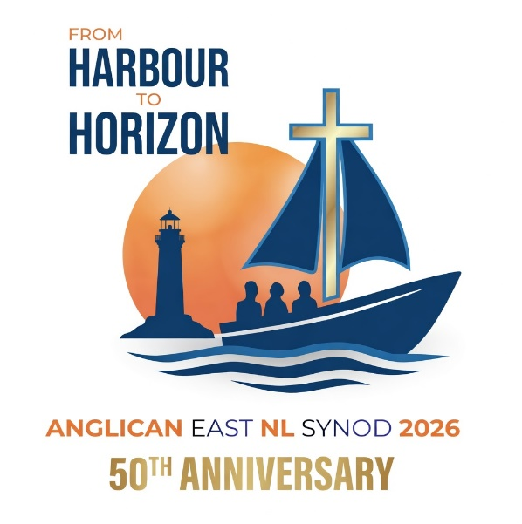

Announcement of Diocesan Synod Theme and Logo

The Anglican Diocese of Eastern Newfoundland and Labrador is pleased to announce the theme for our upcoming Synod, marking our 50th Anniversary as a Diocese:

“From Harbour to Horizon: Charting Christ’s Course 1976 to 2026...and Beyond.”

We announce our upcoming Diocesan Synod on September 18-19, 2026, with our special guest, the Primate of the Anglican Church of Canada, Archbishop Shane Parker.

The Opening Synod Eucharist on Friday, September 18, at our Cathedral is open to all. Synod proceedings on September 18-19 are for elected delegates only.
This theme will guide our gathering as we give thanks for 50 years of God’s faithfulness since our founding in 1976, celebrate the progress of our Set Sail Strategic Plan launched in 2023, reflect on the Four SHIPS priorities, and discern the future course Christ is setting for our mission and ministry in Newfoundland and Labrador.

Further details will follow.

St John the Evangelist Anglican Church

May 9, 20 Rectory Rd
Topsail, CBS
9AM to 1PM
Admission $2.00

Saturday May 9th
20 Rectory Rd

