|  |
| --- |
| ***Worship Calendar***  **Sunday, May 4th, Third Sunday of Easter**  **10:30 a.m.** (White) **Family Prayers in Easter** followed by a Cup O’ Tea in the Parish Hall (AG Team 1) Deacon Lisa Cox (Officiant)  Acts 9: 1 – 6 Glenda Tapp Psalm 30 Revelation 5; 11 – 14 Sandra Squires John 21: 1 – 19  **Sunday, May 11th, Fourth Sunday of Easter**  **10:30 a.m. (**White) **Holy Eucharist** with Family Ukulele Ministry (AG Team 2) (EA Donald Sparkes) Archdeacon Greg Mercer (Presider)  Acts 9: 36 – 43 Shirley Butt Psalm 23 Revelation 7: 9 – 17 Rev. Emeline Coffin John 10: 22 – 30  **Sunday, May 18th, Fifth Sunday of Easter**  **10:30 a.m.** (White) **Morning Prayer in Easter** (AG Team 3) Deacon Lisa Cox (Officiant)  Acts 11: 1 – 18 Robert Dawe Psalm 148 Revelation 21: 1 – 6 Donna Dawe John 13: 31 – 35 |

**A Note from the Treasurer:** Please ensure your **envelope number is on** all financial **correspondence** so that we can credit your account for income tax purposes.

**Parish Office hours are Monday – Thursday, 9:00 a.m. – 1:00 p.m.**

**Sunday Bulletins -** If you’d like to give a weekly bulletin to commemorate the life of a loved one or in Thanksgiving for an event in your life, please contact David in the office for the dates available.

***Service Roster:*** Sidespersons Sound Room

May 4th Gail T. Andrew B.

May 11th  Ken C. Jim S.

May 18th  David M. Philip G

|  |
| --- |
| Bishop: The Right Reverend Samuel Rose  Diocesan Administrator: The Venerable Charlene Taylor  Rector: The Reverend Canon Josiah “Jotie” Noel, T.S.S.F.(Third Order, Society of St. Francis)  Parish Deacon:  The Reverend Lisa Cox  Organists/Choir Director: Stephanie Gavell, Amanda Dawe-Ledwell  Parish Wardens: Rex Hillier & Leanne Squire  Office Administrator: David Kelland |

**Welcome to the**

**Parish of St. John The Evangelist**

**Conception Bay South, Newfoundland**

**April 27, 2025**

Second Sunday of Easter



[www.stjohntheevangelistnl.com](http://www.stjohntheevangelistnl.com/)

Facebook: SJTE Topsail

Office email: [sjtetopsail@nfld.net](mailto:sjtetopsail@nfld.net)

Office phone number: 709-834-2336

Address: P.O. Box 13033, CBS, NL, A1W 2K1

E-transfer: sjtetopsail@nfld.net

Rector Email: jotienoel@gmail.com

Rector’s Cell: 709-325-2366

***Our Parish Mission Statement***

***We believe in nurturing a community of faith dedicated to inclusion, support and sharing the story of God's love with all people regardless of the stage of their spiritual journey***

The Parish live-streams our regular Sunday Services and posts to Facebook

***A Pilgrim’s Prayer***

*Guardian of my soul*

*Guide me on my way today.*

*Keep me safe from harm,*

*Deepen my relationship with you,*

*your earth, and all your family.*

*Strengthen your love within me*

*that may be a presence of*

*your peace in our World. Amen (Rupp & Pfeffer)*

Twenty years ago, I took an eight-day silent retreat with the Jesuit’s in Guelph. It was a very engaging experience leaving me with an appetite for more. So, I planned to take silence to the next level with a 40 Day Silent Retreat one day. I would use the Spiritual Exercises of St. Ignatius designed for this purpose.

As time unfolded I realized that a 40 Day Silent Retreat in a cell does not really reflect my spiritualty. As a Third Order Franciscan my spirituality reflects movement, creation, and encountering people. Franciscans do practice contemplation and take retreats as we live with our families fully in the community. We are immersed in the affairs of the world.

My 40 Day Retreat plan for 2001 was interrupted by Covid – 19. My focus is a 40 Day Pilgrimage walking the Camino de Santiago de Compostela in Spain. The time is ripe for me to undertake this pilgrimage as I set my thoughts and prayers toward what God is calling me to be for the future.

The Camino de Santiago (or the Way of St. James in English), is a network of pilgrims' ways or pilgrimages leading to the shrine of the apostle James in the cathedral of Santiago de Compostela in Galicia in northwestern Spain. Tradition holds that the remains of the apostle are buried there. Pilgrims follow their routes as a form of spiritual path or retreat for their spiritual growth.

The Parish decision to terminate my full-time position as Rector of St. John the Evangelist has contributed to my intention to undertake this pilgrimage at this time. I will be away from the last week in April until mid-June walking the Camino Frances route to Santiago.

There are multiple routes of various lengths to reach Santiago, each with their own peculiarity and unique experience. The longest and most popular is the Camino Frances from St. Jean Pied de Port, France, to Santiago, Spain, about 780Km. Depending on the time of year, the number of pilgrims varies significantly. There are multiple options for accommodations – four types of hostels, B&B, hotels, etc. This route is sometimes called the Café Camino as there are many options to dine enroute.

***A Prayer for Pilgrims***

*Teach Pilgrims, O God, to view their life here on earth as a pilgrim’s path to heaven,*

*And give them grace to tread it courageously in the company of your faithful people.*

*Help them set their affections on things above,*

*Not on the passing vanities of this world,*

*And grant that as they journey on in the way of holiness*

*they may bear a good witness to our Lord,*

*and serve all who need our help along the way,*

*for the glory of your name. Amen. (Camino Santiago)*

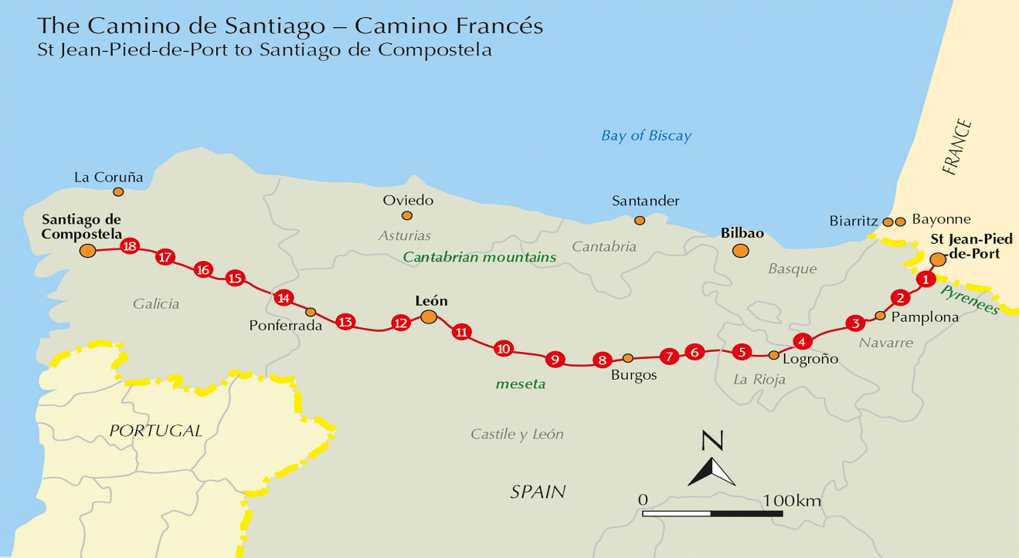

Flea Market

**Saturday, May 10, 2025**

**9:00 AM to 1:00 PM**

**All donations for the Flea Market are gratefully accepted. Among the items requested are:**

**Flea Market:**

Lamps; Dishes; Pots & Pans; Backpacks; Kids Toys and Puzzles; Old Records, CD’s & DVD’s; Books, Christmas Items & Decorations; Household & Cabin Items; Work Tools and Power Tools; Small Appliances; Plug in Heaters etc., etc.

**Please note we cannot accept:** Electronic Items; VHS Tapes, Coffee/End Tables; Computers; Tires; Heaters; Blinds; Clothing; Car Seats; Highchairs; Building Materials

**Drop off times for donations are as follows:**

Thursday, May 8, 6:30 PM to 8:00 PM.

Friday, May 9, 10:00 AM to Noon.

& 6:30 PM – 8:00 PM

**Contact: Rex Hillier – 709 834 4434**

**Thank you!**

**St. John the Evangelist Parish**

**Spring Lasagna Take Out**

**Saturday, May 03, 2025**

(pick up between 3:30 and 5:00 pm)

Lasagna, Caesar salad, roll and dessert

$15.00

To Order, please call

Louise @ (709) 834-7385

Shirley @ (709) 368-9504

**Order deadline: Tuesday, April 29**

Thank you for your support!

**Easter Flowers: -** Donations towards the Easter Flowers gracing our Sanctuary have been given to the Glory of God and

**Summer Job Opportunity**

St John the Evangelist Anglican Church Topsail

is looking to hire

the following students for work

on the church property and in the cemetery.

Starting on July 2nd

1. One youth for 8 weeks at 35 hours per week.

(Canada Summer Jobs confirmed)

1. One youth for 6 weeks at 20 hours per week.

(Pending approval of NL Summer Jobs)

Applications with resumes should be emailed

to

[sjtetopsail@nfld.net](mailto:sjtetopsail@nfld.net) by **May 7th**.

**in Loving Memory of: Remembered by:**

Alma Fudge Her daughter & Family

All to whom I have said goodbye Gail Trewhitt

here on earth, but forever hold

In my heart

**A donation has been given the Cemetery Fund to the Glory of God** and

Loving in Memory of Laura Hiscock and the family of John and Martha Barnes. Remembered by the late Hayward & Lillian Hiscock.

**We invite prayers for those who are sick**: Cassidy B., Patricia B., Elaine M., Doug T., Tammy H., Jeanette P., Wally H., Ruby H., Eva B., Hayden P., Cynthia W., Scott S., Don M., Colin C., Hilda S., Elaine C., Lois B.

**St. John the Evangelist Annual Meeting** – The Vestry is preparing to have our Annual Congregational meeting on **Sunday, May 4**, following family prayers at 10:30 a.m. in the Parish Hall. With this is mind, we will need to fill two vestry positions – each for two years. If you feel you would like to fill one of these positions, please let Donald Sparkes or Rex Hillier know.

**Pastoral Emergencies / Questions**

If you require the services of a Parish Priest in the next several weeks while Canon Jotie is away,

please contact the Parish Office or Archdeacon Gregory Mercer at 709 730-5524.