|  |
| --- |
| ***Worship Calendar***  **Sunday, December 1, First Sunday in Advent, 10:30 a.m.** (Blue) **Family Prayers**, followed by a Cup O’ Tea In the Parish Hall (AG Team 2)  The Jesse Tree  **Sunday, December 8, Second Sunday in Advent, 10:30 a.m.** (Blue) **Advent Procession & Holy Eucharist** (AG Team 3) (EA – Gail Trewhitt)  Genesis 2: 4b – 9, 15 – 25 Sandra Squires Genesis 3: 1 – 15 Shirley Butt Exodus 3: 1 – 6 Louise Smith  Isaiah 11; 1 – 10 Sharon Smith Micah 5: 2 -4 Donald Sparkes Isaiah 7: 10 – 15 Glenda Tapp Luke 1: 26 – 38  **Sunday, December 15, Third Sunday in Advent, 10:30 a.m.** (Blue) **Holy Baptism & Holy Eucharist** (AG Team 1) (EA – Donald Sparkes) |

**A Note from the Treasurer:** Please ensure your **NAME & ENVELOPE NUMBER** are onall financial **correspondence** so that we can credit your account for income tax purposes.

**Regular Parish Office hours are Monday – Thursday, 9:00 a.m. – 1:00 p.m.**

**Service Roster: Sides Persons Sound Room**

December 1st Gail T. Jim S.

December 8th John C. Bob D.

December 15th Ken C. Philip G.

December 22nd David M. Jim S.

|  |
| --- |
| Bishop: The Right Dr. Reverend Samuel Rose  Diocesan Administrator: The Venerable Charlene Taylor  Rector: The Reverend Canon Josiah “Jotie” Noel, T.S.S.F. (Third Order, Society of St. Francis)  Parish Deacon:  The Reverend Lisa Cox  Organists/Choir Director: Stephanie Gavell, Amanda Dawe-Ledwell  Parish Wardens: Rex Hillier & Donald Sparkes  Office Administrator: David Kelland |

**Welcome to the**

**Parish of St. John The Evangelist**

**Conception Bay South, Newfoundland**

**November 24, 2024**

**The Reign of Christ**

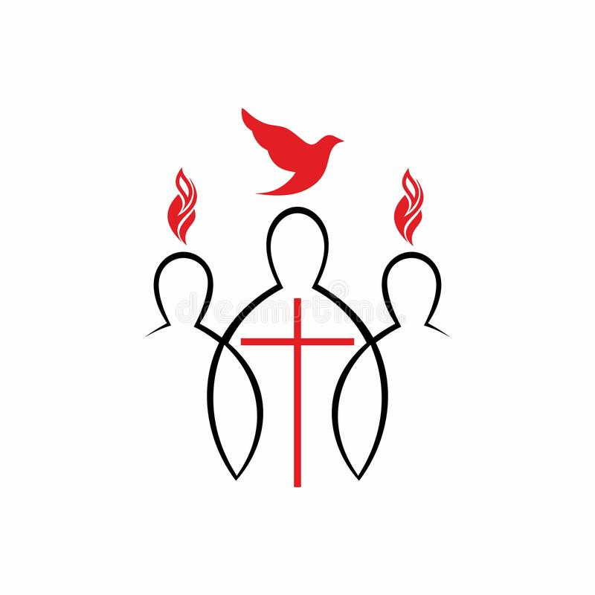

This Bulletin is given to the Glory of God

and in Thanksgiving on the occasion of the Birthday

of our Brother, Wally Hiscock.

from his sisters and brothers.

www.stjohntheevangelistnl.com

Facebook: SJTE Topsail

Office email: sjtetopsail@nfld.net

Office phone number: 709 834-2336

Rector Email: jotienoel@gmail.com

Cell: 709 325-2366

***Our Parish Mission Statement***

***We believe in nurturing a community of faith dedicated to inclusion, support and sharing the story of God's love with all people regardless of the stage of their spiritual journey***

The Parish live-streams our regular Sunday Services and posts to Facebook

I am grateful to have the opportunity to extend a warm welcome to you as you attend our Celebration of Holy Eucharist this morning. As we gather to celebrate the last Sunday in the Church’s year, The Reign of Christ, we give thanks for this past year. We look to the new year, beginning in Advent, with hope, peace, joy and love culminating in the birth in time of the timeless Son of God, Jesus, the Christ.

Every good wish in Christ,

Canon Jotie, TSSF

*Hymns for Today*

Processional 383 CP Jesus Shall Reign Where’er The Sun

Gradual 345 CP King of Glory, King of Peace

Offertory 380 CP O Worship The King

Mission 378 CP Crown Him With Many Crowns

*Collect for Today*

Almighty and everlasting God, whose will it is to restore all things in your well-beloved Son, our Lord and King, grant that the peoples of the earth, now divided and enslaved by sin, may be freed and brought together under his gentle and loving rule; who lives and reigns with you and the Holy Spirit, one God, now and for ever. Amen.

*Lessons for Today*

2 Samuel 23: 1 – 7 Betty Hiscock

Psalm 132

Revelation 1: 4b – 8 Maxine Reccord Pinhorn

John 18: 33 – 37

*Prayer over the Gifts*

Eternal God, by your grace you have raised us up and enthroned us with Christ in the heavenly realms. Receive all we offer you this day, and lead us in those good works for which you have created us. We ask this in the name of Jesus Christ the Lord. Amen.

Prayer After Communion

Almighty God, you have made us a royal priesthood in the kingdom of your Son our Saviour Jesus Christ. Make known his victory through us, we pray, that all the world may see his light. We ask this in the name of Jesus Christ the Lord. Amen.

**We invite prayers for those who are sick**: Patricia B. Elaine M., Benjamin C., Doug T., Tammy H., Wally H., Trudy T., Ruby H., Kelly R., Eva B., Hayden P., Cynthia W., Christine H., Danielle B., Denise P., Richard R., David R.

**In Memory -** A donation has been made to the Parish of St. John the Evangelist, to Glory of God and in Loving Memory of Parents, Harold & Margaret Tucker and Victor & Lillian Jefford. Remembered by Wayne & Barbara Tucker.

**-** A donation has been made to the Parish of St. John the Evangelist, to Glory of God and in Loving Memory of Harold Butt. Remembered by his two sons.

**St. John the Evangelist Vestry Meeting** – Thursday, **November 28**, 7:00 p.m.

**Parish Home Visits** – Reverend Jotie is ready, willing, and able to visit you in your home. Under the circumstances of time and place, this offer comes with the understanding that he will respond to invitations. Please call him to invite him to visit your home if you wish.

**Bible Study, LUKE** – Our next Bible Study will be, Thursday, November 28, at 10:30 a.m. Join us as we continue to study the Gospel of Luke references for Sunday worship. If you do not have a Bible, we can provide one for you, as well as a large print copy of the lesson for the study.

**Pilgrimage in the Park** – Join us for a prayer walk in Chamberlain’s Park on **Tuesday November 26th, 10:30 a.m.** – Our theme for this pilgrimage will be Autumn.

Pilgrimage on any scale is an opportunity to awaken to the wonder and beauty of the world around us. In breaking from the daily routine, we are able to move out of our familiar ruts in order to re-examine our relationship with the MYSTERY OF LIFE. Our pilgrimages support opening and deepening awareness to the present moment, to our bodily senses, and to expanding conscious relationships with Creation as we seek and find in the Park.

*Chamberlains Park is a 16-acre wetland located in Chamberlains, Conception Bay South (CBS), NL. The Main Entrance is 1.5 kilometers east of Manuels Bridge on Route 60. From the Main Entrance, walk the 1 kilometer wheelchair-friendly trail of boardwalk, gravel and sidewalk which leads through the forest, across the park bridge to Chaytor’s Road, and along the Route 60 sidewalk back to the entrance. (Chamberlain’s Park Pamphlet)*

**Food Bank Christmas Hampers –** If you are interested in contributing to the Christmas hampers, please consider a monetary contribution; which would be greatly appreciated and are needed as soon as is possible. Cheques may be made out to the Paradise / CBS Food Bank or to the Parish of St. John the Evangelist with a notation directing the money to the food bank. Any questions please contact Gail Trewhitt at 709-834-3909

**Bishop’s Letter regarding “A Sacred Trust”**

**November 17, 2024**

Dear Friends,

Grace and peace to you in Jesus Christ.

As many of you may know, the Archbishop of Canterbury, Justin Welby, offered his resignation last week following the Makin Review in the Church of England. To read the Archbishop’s Letter of resignation, visit the website <https://www.archbishopofcanterbury.org/news/news-and-statements/statement-archbishop-canterbury-0>

In response, our Primate, Archbishop Anne Germond, issued a Pastoral Letter to the Anglican Church of Canada, stating: “*The Anglican Church of Canada is committed to continuing the work necessary to make the church a safe place for everyone, in line with our baptismal covenant to respect the dignity of every human being. We pray for the humility, courage, and wisdom required for this crucial task.”*

To read the Primate’s full letter, please visit the Anglican Church of Canada’s website at <https://www.anglican.ca/news/statement-on-the-resignation-of-the-archbishop-of-canterbury/30047750/>

Our Diocese of Eastern Newfoundland and Labrador has had a Safe Church policy titled “A Sacred Trust” for many years. This policy represents our commitment to ensuring our church is a safe and holy place for all. As our Baptismal Covenant states, we are called to seek and serve Christ in all persons, loving our neighbours as ourselves (Book of Alternative Services, p. 159). Therefore, it is our solemn responsibility to actively promote the welfare of all members of our community, especially those vulnerable due to age, infirmity, or other pastoral circumstances. This is a sacred trust which must be responsibly and safely managed.

To be clear, anyone - clergy, employees, and laity - working or volunteering in our Diocese with children, youth and vulnerable persons must be fully aware and compliant with “A Sacred Trust” without exception.

As “A Sacred Trust” states in section 19:

*19. All stipendiary clergy and employees, as a condition of employment, as well as all non-stipendiary clergy and volunteers eighteen years of age and older, holding positions identified as involving risk, as a condition of voluntary service, must then:*

1. a. receive and read a copy of, and participate in an orientation to A Sacred Trust;
2. b. agree in writing to comply with A Sacred Trust (Annex C); and
3. c. apply for a ‘Certificate of Conduct’ and a ‘Vulnerable Sectors Check.’

To familiarize yourself with our Diocesan policy, “A Sacred Trust,” visit our website: <https://anglicanenl.net/wp-content/uploads/2023/06/Sacred-Trust-Updated-June-19-2023.pdf>

As we move forward, let us not only offer our prayers for those who have suffered abuse and maltreatment in the church but also take meaningful action to ensure that such harm is never repeated. As a church, we are called to be a community of healing, justice, compassion, and unwavering commitment to protecting the vulnerable. May we be ever mindful of the sacred trust placed in us as the body of Christ, and may our hearts be open to both the suffering of the victims and the necessary work required to respect the dignity of every human being and protect the most vulnerable in society. May we, as individuals and as a Church, commit ourselves to creating a safe, welcoming, and trustworthy place for all to encounter Christ's love.

Let us walk this difficult but necessary path together in prayer, respect, and action.

In Christ’s love,



The Right Rev. Samuel Rose

Bishop of Eastern Newfoundland and Labrador