Worship Calendar

The Baptism of The Lord, Sunday, January 14th 2024
10:30 a.m. – (White) Holy Eucharist (AG Team 1)

Epiphany 3, Sunday, January 21st 2024
10:30 a.m. – (Green) Holy Eucharist (AG Team 2)

Epiphany 4, P.W.R.D.F. Sunday, January 28th 2024
10:30 a.m. – (White) Holy Eucharist (AG Team 3)

2024 Envelopes - If you need a new box of envelopes for 2024, please contact the parish office by email sjtetopsail@nfld.net or call 709-834-2336. We also have the option of Pre-Authorized payment or e-transfer. To learn more about these options please call the Parish Office.

A Note from the Treasurer: Please ensure your envelope number is on all financial correspondence so that we can credit your account for income tax purposes.

Parish Office hours are Monday – Thursday, 9:00 a.m. – 1:00 p.m.

Parish E-mail List – We have begun e-mailing the Sunday Bulletin on the previous Thursday and will be sending other information of Parish Life from time to time. If you would like to add your name to this Parish List, please call the Office or email us at sjtetopsail@nfld.net

Service Roster: Sidespersons Sound Room
January 14th Dianne H. Andrew B.
January 21st Leanne S. James S.
January 28th Tracey C. Philip G.

Bishop: The Right Reverend Samuel Rose
Diocesan Administrator: The Venerable Charlene Taylor
Rector: The Reverend Jotie Noel, T.S.S.F.(Third Order, Society of St. Francis)
Parish Deacon: The Reverend Lisa Cox
Organists/Choir Director: Stephanie Gavell, Amanda Dawe-Ledwell
Parish Wardens: Rex Hillier & Leanne Squire
Office Administrator: David Kelland

Welcome to the Parish of
St. John the Evangelist
Conception Bay South, Newfoundland

Epiphany of the Lord
January 7, 2024

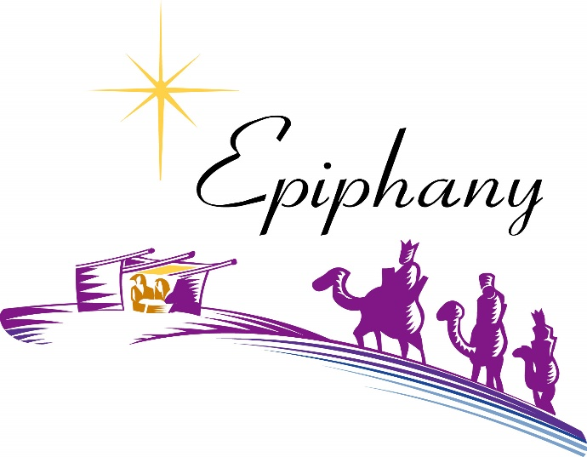

www.stjohntheevangelistnl.com
Facebook: SJTE Topsail
Office email: sjtetopsail@nfld.net
Office phone number: 709-834-2336
Address: P.O. Box 13033, CBS, NL, A1W 2K1
E-transfer: sjtetopsail@nfld.net
Rector Email: jotienoel@gmail.com
Rector’s Cell: 709-325-2366

Our Parish Mission Statement
We believe in nurturing a community of faith dedicated to inclusion, support and sharing the story of God's love with all people regardless of the stage of their spiritual journey

‘We have seen his star in the East, and have come to worship him’ Matthew 2.2

We are also like the magi! In fact, seeing the magi give their gifts to the baby Jesus and kneel in homage to him ought to remind us of ourselves. What else are we doing here in Church on Sundays if not giving to and worshipping before Jesus?

Those magi therefore might be called the very first church, the very first to bend the knee and worship Jesus. From them, the magi, this baby and the journey that he calls them to undertake, is a source of great joy, rather than a cause of deep fear.

They, “departed by another road for their own country.”

Are we willing to go on that journey with joy, to relinquish our sense of comfort and control
and go where the star, and its Lord can lead us?

Can we, as the Church, rise with this shining new star and rise to a new sense of adventure, forsake our cozy boundaries, and go forth following him?

Perhaps that is the chief requirement for being a Christian – a willingness to go on a journey, like the people in our Diocese who are invited by our Bishop to Set Sail. Have you ever thought of Christianity as a verb instead of a noun; a way of life more than belief statements?

I fear that too many of us gather here in order to settle in, settle down, as if church were the end of the journey with God, rather than its beginning and its path.

We follow a living Lord, a demanding Saviour, who leads us forward, in whose service is high adventure. Let us follow that star. Jotie, TSSF

Almighty and everliving God, you revealed the incarnation of your Son
by the brilliant shining of a star.
Shine the light of your justice in our hearts and over all lands,
and accept our lives as the treasure we offer in your praise and for your service;
through Jesus Christ, our Saviour and Lord, who lives and reigns with you and the Holy Spirit,
one God, now and forever. Amen. (ACC)

Sundays at 7 - This evening, Sunday, January 7th, you are most welcome to join the Clergy and St. John the Evangelist Choir as we visit Admiral’s Coast Retirement Home for the service of Evening Prayer, at 7:00 p.m.

We invite prayers for those who are sick - Patricia B., Elaine M., Benjamin C., Doug T., Tammy H., Jeanette P., Wally H., Trudy T.

DIOCESAN ANGLICAN MEN’S ASSOCIATION [DAMA] - There will be a service and dinner meeting of DAMA at St. Philp’s Anglican Church on Sunday, January 28, 2024. Dinner is at 5:00pm. The meeting will begin at 6:00pm and will be followed by a service at 7:00pm. Bishop Sam Rose will be the guest speaker. This is open to all men of the diocese. If you are interested in attending, please RSVP by JANUARY 25, 2024 to Gary Kink at 709-691-3902 or Harvey Hiscock at 709-697-5280.

Volunteers Needed - If you’re interested in becoming more involved in the life of your Parish, why not consider volunteering to serve on a “Counting” Team or as a Technician in the Sound Room.?
Training is provided, and the time commitment would only be an hour or two, every month to 6 weeks. Many hands make light work! If this sounds like something you’d like to do, contact David in the Parish office at sjtetopsail@nfld.net or at 709-834 2336.

2024 Bulletins - If you’d like to give a weekly bulletin to commemorate the life of a loved one or in Thanksgiving for an event in your life, please contact David in the office for the dates available.

Set Sail - Life on Board - A Bible Study Series based on suggested Lessons for Season of Creation 2023, “Let Peace and Justice Flow Down like a River,” will take place on Wednesday mornings at 10:30 a.m. Wednesday, January 17, 2024 - Matthew 18; 21-35 (Forgive is our Debts)

Parish Home Visits – The dynamic of the times still provides many issues for clergy home visit ministry. As we continue to emerge out of the pandemic and still live with it, Canon Jotie is ready, willing, and able to visit you in your home. Under the circumstances, this offer comes with the understanding that he will respond to invitations. Please call him to invite him to visit your home if you wish for conversation, prayers, or Home Communion.

The Laying on of Hands – In preparation for the sacrament of Confirmation, Sunday, May 26, 2024, 10:30 a.m. we plan to start Confirmation Classes in late January. Confirmation Candidates should currently be in Grade 6 or older. Please contact the Church Office to register or for more information (834-2336 or sjtetopsail@nfld.net).
We are ready, willing and able to prepare adults for Confirmation if you may be interested. Please contact Reverend Jotie for details.

Family Ukulele Group - The Family Ukulele Group is a music ministry of the parish and is open to ALL ages. No prior musically knowledge or experience is needed. Practice lessons are the first and third Sundays of each month immediately following the 10:30 service. We resume lessons in January 2024. Ukuleles are available for purchase through the office for approximately $50. To register for the group call David at the office. Be sure to let him know if you will be needing a Ukulele. If you are unable to purchase one please contact Canon Jotie.

