Worship Calendar

Sunday, December 24, Christmas Eve
11:00 a.m. Holy Eucharist
4:00 p.m. Blessing of the Creche & Holy Eucharist (Ukulele Ministry)
7:00 p.m. Holy Eucharist

Sunday, December 31, Sunday after Christmas
10:30 a.m. Christmas Lessons & Carols

Sunday, January 7, The Epiphany of Our Lord
10:30 a.m. Family Eucharist
Followed by a Cup O’Tea in the Parish Hall
7:00 p.m. Evening Prayer – Admiral’s Coast Retirement Home

Parish Office Christmas Hours

In keeping with the Diocesan Synod Office Christmas hours, The Parish Office will be closed from Thursday, December 21st to Tuesday, January 2nd 2024
Regular office hours (9:00 a.m. to 1:00 p.m.) will resume on Wednesday, January 3rd, 2024

A locked mail drop box is available at the office entrance for your convenience.
If you have an emergency during the Christmas season, please contact: Reverend Jotie @ 709 325-2366

Service Roster: Sidespersons Sound Room
December 24th Gail T. Robert D.
December 31st John C. Philip G.

Bishop: The Right Reverend Samuel Rose
Diocesan Administrator: The Venerable Charlene Taylor
Rector: The Reverend Canon Josiah “Jotie” Noel, T.S.S.F. (Third Order, Society of St. Francis)
Parish Deacon: The Reverend Lisa Cox
Organists/Choir Director: Stephanie Gavell, Amanda Dawe-Ledwell
Parish Wardens: Rex Hillier & Leanne Squire
Office Administrator: David Kelland

Welcome to the Parish of
St. John The Evangelist
Conception Bay South, Newfoundland
Christmas Bulletin 2023
(Christmas Eve, December 24th, Sunday after Christmas, December 31st)

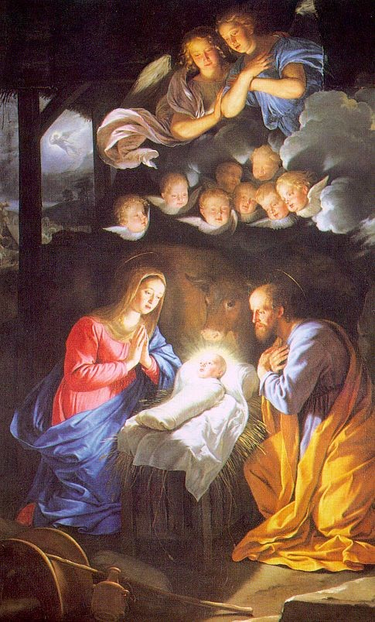

This Bulletin is given to the Glory of God
and in Loving Memory of
Parents, Rosa & Bob Chaytor
Remembered by their Children, Allison, Janice, Heather, Sandy & Stephen and their spouses; 12 Grandchildren and 2 Great-Grandchildren

www.stjohntheevangelistnl.com
Facebook: SJTE Topsail
Office email: sjtetopsail@nfld.net
Office phone number: (709) 834-2336
Rector Email: jotienoel@gmail.com
Cell: (709) 325-2366

Our Parish Mission Statement
We believe in nurturing a community of faith dedicated to inclusion, support and sharing the story of God's love with all people regardless of the stage of their spiritual journey
And the Word became flesh and lived among us, and we have seen his glory, the glory as of a father’s only son, full of grace and truth. John 1: 14

We have gathered in this beautiful place on this beautiful day to celebrate the birth of the Christ, Messiah. We are truly present with all our joys and sorrows, hopes and fears, and gratitude in the midst of confidence and uncertainty.

This place is beautiful, and the music is grand. And that’s fine. But let us never forget that for the church, Christmas is the Feast of the Incarnation. The Word became flesh, flesh and bone, living dust, incarnate, among us. Us.
A God who limits presence to mountaintop experiences, warm fuzzies, exclusive cliques, or hand-holding around the lake at summer camp could not help us.

We need a God who does not mind living in places like Bethlehem. Bethlehem, where despite the present war between Israel and Hamas, Arab and Jew live in uneasy peace, where vendors hawk their wares, and horns honk, and there is anxiety, stress, illness, loneliness, hunger, fear of the future, financial disaster, wayward teenagers, dissolving marriages, and all the rest.

When you leave here this morning/afternoon/evening, after this hour of holiness, take one thought with you as you go back to whatever Bethlehem you call home: The person from Bethlehem, his name was Immanuel, God with us, God with us. The Word became flesh and dwelt among us. May we become more fully aware of his presence in whatever Bethlehem we call home.

“See, the home of God is among mortals, He will dwell with them as their God; they will be his people, and God himself will be with them;...” (Rev 20:3-4).
Merry Christmas! Canon Jotie, TSSF

God of promise, from ancient times you have sustained your people.
With Mary and Joseph,
teach us to treasure in our hearts the birth of Jesus,
and with shepherds and angels,
lead us to praise the holy Child of Bethlehem
in whose name we pray. Amen. (ACC)

Parish Home Visits – The dynamic of the times still provides many issues for clergy home visit ministry. As we continue to emerge out of the pandemic and still live with it, Canon Jotie is ready, willing, and able to visit you in your home. Under the circumstances, this offer comes with the understanding that he will respond to invitations. Please call him to invite him to visit your home if you wish for conversation, prayers, or Home Communion.

The Laying on of Hands – In preparation for the sacrament of Confirmation, Sunday, May 26, 2024, 10:30 a.m. we plan to start Confirmation Classes in late January. Confirmation Candidates should currently be in Grade 6 or older. Please contact the Church Office to register or for more information (834-2336 or sjtetopsail@nfld.net).
We are ready, willing and able to prepare adults for Confirmation if you may be interested. Please contact Reverend Jotie for details.

Family Ukulele Group - The Family Ukulele Group is a music ministry of the parish and is open to ALL ages. No prior musically knowledge or experience is needed. Practice lessons are the first and third Sundays of each month immediately following the 10:30 service. We resume lessons in January 2024. Ukuleles are available for purchase through the office for approximately $50. To register for the group call David at the office. Be sure to let him know if you will be needing a Ukulele. If you are unable to purchase one please contact Canon Jotie.

Thanks from the Noel’s – To everyone who offered seasonal wishes, cards and gifts, we want to say a hearty thanks – Reverend Jotie & Pauline Noel.

Sunday School – We have used a variety of Programs for our Sunday School curriculum. Most recently, we have used Godly Play – a program widely recognized and encouraged in the Diocese. The commitment to offer this program is substantial. If you are interested in helping us reestablish a Sunday School program, we are open to other possibilities. We are able to use a number of options rather than Godly Play. We are familiar with:
- Sermons 4 Kids - Ready made, little preparation required, includes a Lesson based on the one for each Sunday with a variety of activities for young people of various levels – colouring, puzzles, crafts, etc.
- Daily Bread for Kids – Ready made, little preparation required, with a variety of resources available depending on the commitment and levels of our young people.
Please contact Canon Jotie (834-2336) if you are interested in helping to reestablish our Sunday School.

Year End - You are reminded that our financial records for 2023 will close on December 31st ALL contributions must be in by that date to be used for 2023 Income Tax purposes. Any monies received on or after December 31st will be credited to your 2024 account. There is a secure drop box available outside the parish office for your convenience.

2024 Envelopes - If you need a new box of envelopes for 2024, please contact the parish office by email sjtetopsail@nfld.net or call 709-834-2336. We also have the option of Pre-Authorized payment or e-transfer. To learn more about these options please call the Parish Office.

