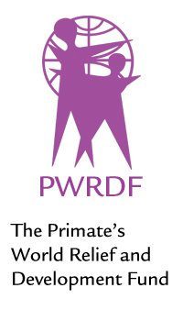
PWRDF
LEARN PRAY GIVE

ZAMBIA

Nearly 33% of Zambian girls marry before age 18 and 6% before their 15th birthday. Poverty forces many parents to take their daughters out of school and offer them in marriage for a bride dowry.

PWRDF has partnered with the Zambian Anglican Council Outreach Program (ZACOP) in its work to end this practice. ZACOP is the development arm of the Zambian Anglican Church. It raises awareness of children’s rights, sexual and reproductive health and rights for the vulnerable.

The program coordinates meetings wih church and local leaders, parents, community workers, peer educators, and girls and boys. It produces radio programs and provides skills training and educational opportunities for those who have entered child marriages. Gender and child-sensitive training is also effective in behaviour changes in adolescents.

It also provides safe places in schools, churches and communities to give greater access to remedial services and activities such as drama and sports.

PWRDF
LEARN PRAY GIVE

ZAMBIA

Nearly 33% of Zambian girls marry before age 18 and 6% before their 15th birthday. Poverty forces many parents to take their daughters out of school and offer them in marriage for a bride dowry.

PWRDF has partnered with the Zambian Anglican Council Outreach Program (ZACOP) in its work to end this practice. ZACOP is the development arm of the Zambian Anglican Church. It raises awareness of children’s rights, sexual and reproductive health and rights for the vulnerable.

The program coordinates meetings wih church and local leaders, parents, community workers, peer educators, and girls and boys. It produces radio programs and provides skills training and educational opportunities for those who have entered child marriages. Gender and child-sensitive training is also effective in behaviour changes in adolescents.

It also provides safe places in schools, churches and communities to give greater access to remedial services and activities such as drama and sports.

