Schedule of Services

Pre-registration is now required for all Church Services, please call the parish office by Thursday 1:00 p.m. to attend Church on the following Sunday. There are pre-registration sheets at the back of the church to sign up for Sunday, December 26th and January 2nd, 2022, because of Christmas week office closure.

First Sunday After Christmas, December 26, 2021
10:30 a.m. Christmas Festival of Lessons and Carols

The Epiphany (In Anticipation), Sunday, January 2, 2022
10:30 a.m. Holy Eucharist (BCP) Birthday Sunday.
Remember to bring your recyclables and donations for the Food Bank.

The Baptism of the Lord, Sunday, January 9, 2022
10:30 a.m. Holy Eucharist (BAS) with Renewal of Baptismal Vows

Parish Office Christmas Hours
In keeping with the Diocesan Synod Office Christmas hours,

The Parish Office will be closed
from Thursday, December 23rd to Thursday, December 30th

We will open on Thursday, December 30th,
from 9:30 a.m. to 11:00 a.m. for year- end counting and deposit

The office will be closed from
Friday, December 31st 2021 to Sunday, January 4th, 2022

Regular office hours (8:00 a.m. to 1:00 p.m.) will resume on
Tuesday, January 4th, 2022

A locked mail drop box is available at office entrance for your convenience.

If you have an emergency during the Christmas season, please contact: Reverend Jotie @ 325-2366

Welcome to the Parish of

St. John the Evangelist
Conception Bay South, Newfoundland
www.stjohntheevangelistnl.com
Facebook: SJTE Topsail
Twitter: @StJohnEvang

Christmas Bulletin 2021

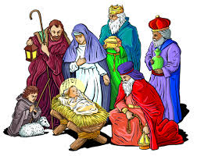

The Bulletin is given to the Glory of God
and in Loving Memory of:

Our Parents,
Victor & Lulu Sparkes & Kenneth & Margaret Reid

By
Donald & Rosalind Sparkes & Family

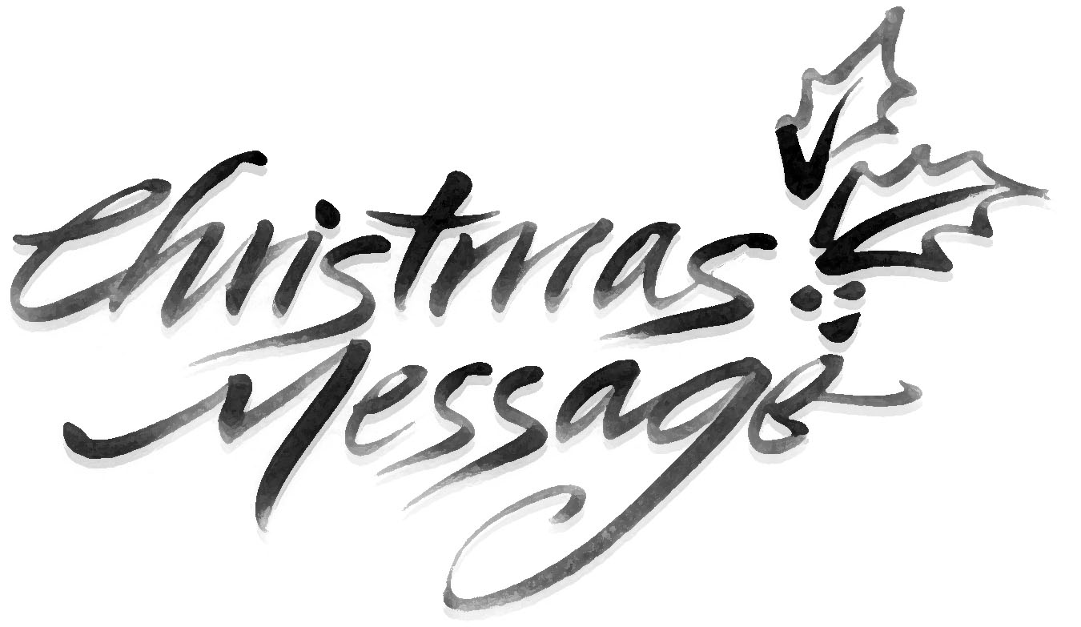
We have gathered in this beautiful place on this beautiful day to celebrate the birth of the Christ, Messiah.
This place is beautiful, and the music is grand. And that’s fine. But let us never forget that for the church, Christmas is the Feast of the Incarnation. The Word became flesh, flesh and bone, living dust, incarnate, among us. Us.
A God who limited himself to mountaintop experiences, warm fuzzies, “Kum Ba Yah,” hand-holding around the lake at summer camp could not help us. We need a God who does not mind living in places like Bethlehem; Bethlehem, where Arab and Jew live in uneasy peace, where vendors hawk their wares, and horns honk, and there is anxiety, stress, illness, loneliness, hunger, fear of the future, financial disaster, wayward teenager, dissolving marriages, and all the rest.
When you leave here this morning/afternoon/evening, after this hour of holiness, take one thought with you as you go back to whatever Bethlehem you call home: The person from Bethlehem, his name was Immanuel, God with us, God with us.
The Word became flesh and dwelt among us. May we become more fully aware of his presence in whatever Bethlehem we call home.
“See, the home of God is among mortals, He will dwell with them as their God; they will be his people, and God himself will be with them;...” (Rev 20:3-4).
Merry Christmas! Reverend Jotie, TSSF

God of promise, from ancient times you have sustained your people.
With Mary and Joseph, teach us to treasure in our hearts the birth of Jesus,
and with shepherds and angels, lead us to praise the holy Child of Bethlehem
in whose name we pray. Amen.

****
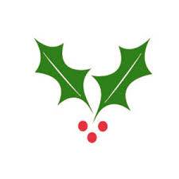
Welcome to all who are joining us for worship today – in person and online, as we come together to praise and worship God. We hope this service will be a blessing to you.
This morning we welcome Archdeacon Greg Mercer who will be Presiding at our 11:00 a.m. Eucharist; this afternoon we welcome Bishop Sam Rose who will be Presiding at our 4:00 p.m. Eucharist.
We offer the invitation for you to join our wide and varied parish family life – worship, fellowship, nurturing or mission.
Year End
You are reminded that our financial records for 2021 will close on December 30th. ALL contributions must be in by that date to be used for 2020 Income Tax purposes. Any monies received after December 31st will be credited to your 2022 account. There is a secure drop box available outside the parish office for your convenience.

Reminder!!!
All committees are asked to have their reports submitted by January 4th for inclusion to the Annual Report.

Reverse Advent Calendar – A special THANK YOU to all who accepted the invitation for the Reverse Advent Calendar to provide some extra food for our local Food Bank. Your food donation was greatly appreciated and you are to be commended to think of others in need at a time when we are making so many preparations for ourselves and our families.

Family Ukulele Group - The Family Ukulele Group is a music ministry of the parish and is open to ALL ages. No prior musically knowledge or experience is needed. Practice lessons are the first and third Sundays of each month immediately following the 10:30 service. We resume lessons on January 16. Ukuleles are available for purchase through the office for approximately $50. To register for the group call Madonna at the office. Be sure to let her know if you will be needing a Ukulele. If you are unable to purchase one please contact Reverend Jotie.

Sanctuary Tables – Thanks to Graham Yetman for making and donating two Sanctuary Tables. We appreciate his craftmanship and generosity.

The Laying on of Hands - Confirmation 2022, Sunday May 15, The Fifth Sunday of Easter – In preparation for the sacrament of Confirmation this coming Easter season we plan to start Confirmation Classes in late January. Confirmation Candidates should currently be in Grade 6 or older. Please contact the Church Office to register or for more information (834-2336 or sjtetopsail@nfld.net).
We are ready, willing and able to prepare adults for Confirmation if you may be interested. Please contact Reverend Jotie for details.

Thanks from the Noel’s – To everyone who offered seasonal wishes, cards and gifts, we want to say a hearty thanks – Reverend Jotie & Pauline Noel.

Covid Surges and Such - In preparation for Christmas, Reverend Jotie had planned to offer Home Communion to those who are sick, shut-in or unable to attend public worship. Given the surge in Covid-19 cases lately, Home Communion Visits and/or Pastoral Visits will take place at a more appropriate and safe time.

