Fall Fair Take – Out Dinner

Stuffed Chicken Breast

Includes vegetables and dessert

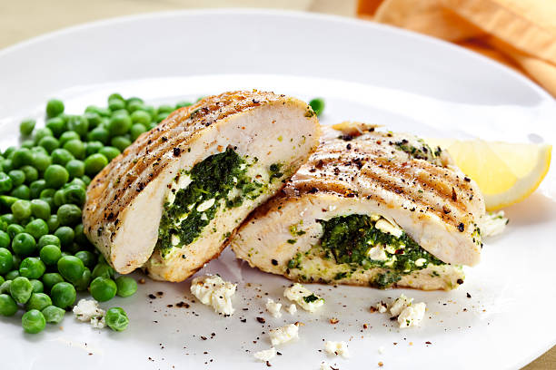

Date: Saturday, November 20, 2021

Pick Up: 3:30 – 5:30 PM,

Location: St. John the Evangelist Parish Hall. 20 Rectory Road, Topsail, NL

Deadline to place an order is Sunday, November 14, 2021

Call Office at 834-2336 to order 9-Noon, Monday to Thursday

Or Rex at 834 - 4434 or Sharon at 330 - 4416

Cost: $20.00

COVID VAX PASS required to enter Parish Hall

Thank You

Fall Fair Take – Out Dinner

Stuffed Chicken Breast

Includes vegetables and dessert



Date: Saturday, November 20, 2021

Pick Up: 3:30 – 5:30 PM,

Location: St. John the Evangelist Parish Hall. 20 Rectory Road, Topsail, NL

Deadline to place an order is Sunday, November 14, 2021

Call Office at 834-2336 to order 9-Noon, Monday to Thursday

Or Rex at 834 - 4434 or Sharon at 330 - 4416

Cost: $20.00

COVID VAX PASS required to enter Parish Hall

Thank You