Reminder
The deadline for Easter Memorial is Tuesday, March 30th
You may drop off your memorials in the drop box located outside the parish office entrance. You can also email the parish office at sjtetopsail@nfld.net If you are sending an e-transfer please put the name(s) of the person(s) to be remembered in the message section of your transfer.

From our Treasurer
Thank you for watching our services on our Facebook page (SJTE Topsail) as we continue to strive to bring the Word of God to each of you. Through your financial support during these difficult times, we are able to keep your church operating. Please continue to support us in this way. You have answered this challenge in the past and I know you will do the same in the future. As I’m sure you are all aware, we are no longer able to do our usual fundraising events. These fundraisers provide significant financial support for our Church. The COVID 19 virus is a challenge to us all, but we will persevere and one day soon we will worship together without fear and enjoy our social times together again. May God Bless and keep you safe. Below are ways to continue to contribute to your church safely:
1. Drop box, which is cleared daily, located outside the office entrance.
2. By mail via Canada Post. - P.O. Box 13033, CBS, NL A1W 2K1
3. By E-Mail transfer to sjtetopsail@nfld.net
4. Pre-authorized debit (PAD) automatic deductions from your bank account. You would need to contact the parish office for details on this option.

Sunday Bulletins
If you would like to give the bulletin in memory of a loved one or in thanksgiving of an event in your life, please call the parish office (834-2336) to book a date. Dates available are: April 11th & 25th, May 2nd, 9th, 16th, & 30th, June 6th, 13th, 20th, September 19th, October 3rd & 31st, November 14th, 21st, 28th, December 5th, 12th, Christmas Bulletin.

Palm Sunday
Collect
Almighty and everliving God, in tender love for all our human race you sent your Son our Saviour Jesus Christ to take our flesh and suffer death upon a cruel cross. May we follow the example of his great humility, and share in the glory of his resurrection; through Jesus Christ our Lord, who is alive and reigns with you and the Holy Spirit, one God, now and for ever. Amen.

Readings
1st Reading: Isaiah 50:4-9a Psalm: 31:9-16
Second Reading: Philippians 2:5-11
Holy Gospel: Mark 14:1-15:47

Welcome to the

Parish of St. John the Evangelist
Conception Bay South, Newfoundland
March 28, 2021

www.stjohntheevangelistnl.com
Facebook: SJTE Topsail
Twitter: @StJohnEvang
Office email: sjtetopsail@nfld.net
Office phone number: (709) 834-2336
Priest-in-Charge Email: archdeacon.gregory@anglicanenl.net
Cell: (709) 325-2366

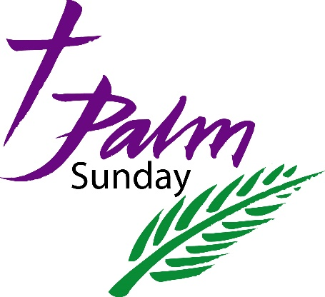

The Bulletin is given to the Glory of God
and in Loving Memory of:
Parents & Grandparents, John G. & Marjorie E. Hillier
&
Husband & Father, Chesley P. Tapp

By

Glenda & Stephen Tapp

Our Parish Mission Statement We believe in nurturing a community of faith dedicated to inclusion, support and sharing the story of God's love with all people regardless of the stage of their spiritual journey
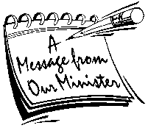
PALM/PASSION Sunday

Dear Friends in Christ,

Palm/Passion Sunday marks the beginning of Holy Week, and it recalls how the people cut branches from trees and spread them on the road as Jesus entered Jerusalem. We have all seen those wonderful images and even more wonderful to envision – the triumphal entry of Jesus into Jerusalem with people waving palm branches. What is the meaning behind the palms?

While only John’s Gospel actual mentions that they were palm branches, and Luke’s Gospel mentions none at all, the image of waving palm branches is strongly etched in liturgical memory. The palm branch is a sign of eternal life and, in the Middle East, the palm tree has always been a tree of honour. Thus, waving palm branches to welcome Jesus was an act that showed how important he was to the people. In churches today, joyful possessions often take place at the beginning of the worship service on Palm Sunday.

Yet, while Palm Sunday begins triumphantly with Jesus entering Jerusalem, it gives way to the most turbulent week of the liturgical year. We begin with a reading of the triumphant entry, and end with a recounting of the betrayal, denial, trial, crucifixion, and burial of Jesus. What begins victoriously with Jesus entering Jerusalem ends in the dark tomb, its door sealed shut.

Holy week and the events leading up to the death and resurrection of Jesus is at the very center of our faith. Christians from all over the world will be paying attention to these events leading up to Good Friday and Easter Day. It is important that we take in as many of these special services as possible. Each will draw our attention to the different events as the drama unfolds. I pray that you will have a great Holy Week experience.

Prayerfully Yours,
Archdeacon Greg+

Tri-Diocesan Intercessions
Parish of Cox’s Cove/McIver’s
Deacon-in-Charge The Rev. Dcn. Terry Loder

Parish of Deer Lake
Priest-in-Charge The Rev. Canon Paulette Bugden

The Sick
Michael, Salem, Paul, Michael C, Randy S, Eleanor M., Fred T.

****
A donation has been given to the Glory of God and in Thanksgiving to the Lord on the occasion of our 70th Wedding Anniversary
March 28, 1951 – March 28, 2021
By
Catherine & Raymond Tooton

Sunday Services
You MUST register each week for Sunday Services. You may do so by emailing sjtetopsail@nfld.net or by calling the parish office @ 834-2336, if there is no answer please leave a message. The maximum number of people that can attend a service is 50, which includes the clergy, choir and volunteers. We suggest that you register as early as possible. Masks must be worn by all people at all times and may only be removed to receive the Eucharist.

HOLY WEEK SERVICES & Easter Sunday
Please register for each service you plan on attending by emailing sjtetopsail@nfld.net (please state which service you will be attending) or by calling the parish office as early as possible.

Wednesday, March 31st – 7:00 p.m. Tenebrae

Maundy Thursday, April 1st – 7:00 p.m. Holy Eucharist and
Stripping of the Altar

Good Friday, April 2nd - 12:00 noon The Passion of Christ Liturgy

Easter Sunday, April 4th - 10:30 a.m.

