Thank you

We extend our thanks and appreciation to Michael Gregory, Amanda Dawe-Ledwell and Sarah Loveys for providing music for our Christmas Eve Services.

Notice

As we await the appointment of a new Rector for our parish the Vestry will provide an update on the services for the month of January. Please continue to check our parish website and facebook page for all future updates.

Are you looking for a church family? Feeling as though you want to get reconnected? We welcome you with open arms. We are an inclusive church who welcomes you here in this place, here you belong and find the love and comfort of our Saviour as well as the church family that surrounds you. We would love to have you with us on Sunday morning’s for worship and as we come together for special services and events. If there is something you are seeking and would like to see happen in our parish then please contact the parish office at 834-2336.

Prayer for those whose Christmas plans have changed

Loving God, surround us this Christmas with your presence: Be with us in our disappointment as our plans have changed, and comfort us with the good news of your love. Help us find moments of joy as we celebrate the coming of Jesus, the child in the manager, who shows your love to the world, and your light in the darkness.
Amen

Welcome to the Parish of

St. John the Evangelist
Conception Bay South, Newfoundland
www.stjohntheevangelistnl.com
Facebook: SJTE Topsail
Twitter: @StJohnEvang

Christmas Bulletin 2020

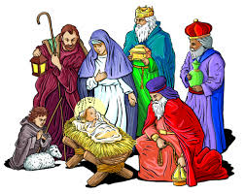

The Bulletin is given to the Glory of God
and in Loving Memory of:

Our Parents,
Willis & Jean Tapper
By
Joan & Gary Szangulies, Linda Coaker,
Pat & Paul Badcock & Their Families
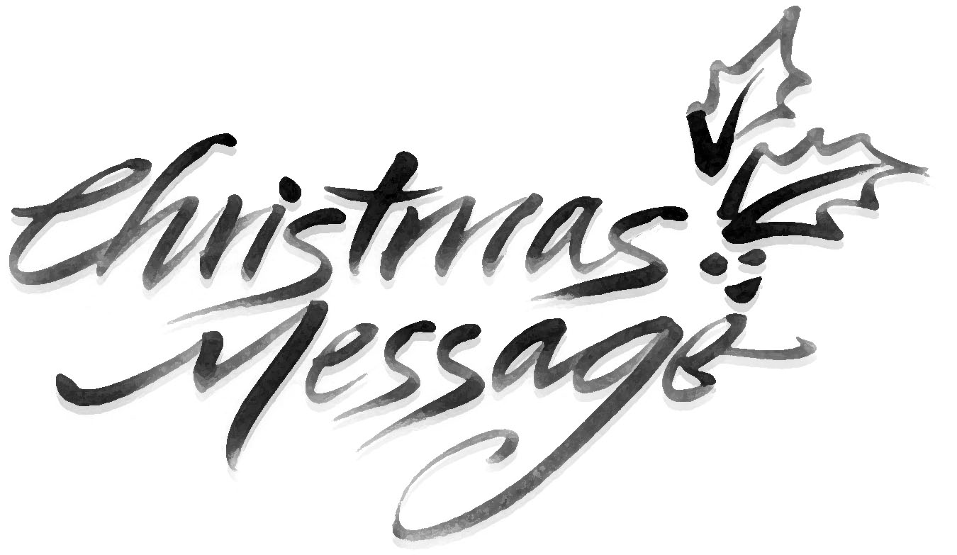
My Dear Friends,
I extend a warm welcome to you this evening. Tonight, we gather together to celebrate the Birth of our Lord and Saviour Jesus Christ. We are filled with such joy on this night as we recall the birth of Jesus so long ago. He is born into our world to fill our lives with love, hope and peace. May we welcome him here among us, welcome him into our hearts this Christmas and invite him to be a part of our journey through life.

I celebrate with you my fifth and final Christmas in parish and give thanks for your kindness, support and care throughout this past year. This has been a very different year for everyone and I know that many of you are struggling with the difficulties that covid-19 has brought into our lives. I pray that God will strengthen you and that you may feel his loving presence. In January, I will be moving on to Barrett’s Funeral Home to work there as a funeral director. I am thankful for the years I have spent with you in this parish and for all that I have learned and experienced. It has been a rich blessing in my life to journey with you. As I move forward, I wish you and your families my every blessing. I pray that God will continue to be a part of your own journey in life. This parish will always remain close in my heart and prayers and I look forward to hearing about the many wonderful things that will take place here in the future. From my family to yours, I wish you a Blessed Merry Christmas.

With My Every Blessing,
Reverend Jolene

Year End
You are reminded that our financial records for 2020 will close on December 31th. ALL contributions must be in by that date to be used for 2020 Income Tax purposes. Any monies received after December 31st will be credited to your 2021 account. There is a secure drop box available outside the parish office for your convenience.

Reminder!!!
All committees are asked to have their reports submitted by January 3rd for inclusion to the Annual Report.

Flowers in the church for Christmas are given to the Glory of God and in Loving Memory of:
Father, Kenneth Reid
by
Rosalind & Donald Sparkes
&
Mom & Dad, Elizabeth & Albert Hiscock, Charles Sparkes & Deceased Loved Ones
by
Shirley Butt, Elizabeth Power & Eugene Hiscock

Parish Office Christmas Hours
In keeping with the Diocesan Synod Office Christmas hours,

The Parish Office will be closed
from Thursday, December 24th to Tuesday, December 29th

We will open on Wednesday, December 30th,
from 9:30 a.m. to 11:00 a.m. for year-end contribution drop off.

The office will be closed from
Thursday December 31st 2020 to Sunday, January 3rd, 2021

Regular office hours (8:00 a.m. to 1:00 p.m.) will resume on
Monday, January 4th, 2021

A locked mail drop box is available at office entrance for your convenience.

If you have an emergency during the Christmas season, please contact: Reverend Jolene @ 325-2366

