Parish Ministries:

Godly Play: Ages 3 and up, takes place every Sunday during our 10:30am services. This is a wonderful program for our children to learn about Jesus’ love for them and the wonders of God all around them.

Music Ministry: Do you sing or play and instrument? We would love to have you perform at one of our 10:30am services. For more information please contact Reverend Jolene.

Senior Choir: We have a beautiful senior choir that really adds to our services, we are always happy to have new members and if you would like to join this wonderful group please reach to our organist and choir director Stephanie Gavell.

Prayer Net: Beginning in January we will have a prayer net located in the back of our church. There will be ribbons of all colours provided for you to tie on the net and offer a prayer for someone or something that is on your heart and mind. More information will be provided in the new year.

Our Sunday Services: are 8:30 am- BCP Holy Eucharist and 10:30 am- BAS Holy Eucharist along with special liturgies. We would love to have you join us on Sunday mornings and be a part of our parish family. For more information contact Reverend Jolene

Are you looking for a church family? Feeling as though you want to get reconnected? We welcome you with open arms. We are an inclusive church who welcomes you here in this place, here you belong and find the love and comfort of our Saviour as well as the church family that surrounds you. We would love to have you with us on Sunday morning’s for worship and as we come together for special services and events. If there is something you are seeking and would like to see happen in our parish then please contact Reverend Jolene.

Welcome to the Parish of

St. John the Evangelist
Conception Bay South, Newfoundland
www.stjohntheevangelistnl.com
Facebook: SJTE Topsail
Twitter: @StJohnEvang

Christmas Bulletin 2019

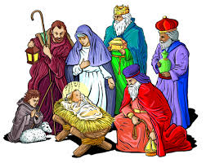

The Bulletin is given to the Glory of God
and in Loving Memory of:

Loved Ones
by
Cliff & Effie Fowler

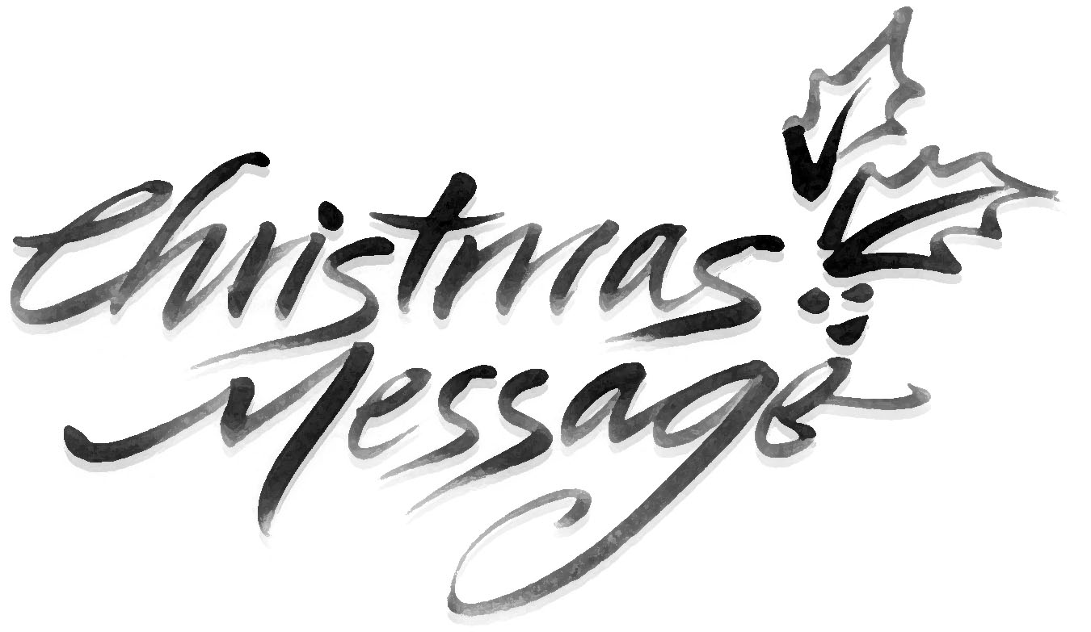
My Dear Friends,

I extend a warm welcome to you this evening. Tonight, we gather together to celebrate the Birth of our Lord and Saviour Jesus Christ. We are filled with such joy on this night as we recall the birth of Jesus so long ago. He is born into our world to fill our lives with love, hope and peace. May we welcome him here among us, welcome him into our hearts this Christmas and invite him to be a part our journey through life.
I celebrate with you my fourth Christmas and give thanks for your kindness, support and care throughout this past year. We have seen some wonderful things take place in our parish and we have done that through the work of all of you who make it all possible. I give thanks to be here among you at this time. I am here for you always, and welcome the opportunity to sit and chat with you whether it be at your home, my office or to meet outside. Please know that you can come to me and that I value the ministry I have in this place with all of you. From my family to yours I wish you a Blessed Merry Christmas!
With My Every Blessing,
Reverend Jolene

A warm welcome to all who are visiting with us this Christmas Season, especially to university students, family and friends who have come home for the holidays.

On behalf of the Anglican Parish of St. John the Evangelist we wish you a safe and joyous Christmas and a Blessed New Year

Reverend Jolene’s Contact: 834-2336, 325-2336

or jolenepeters1@gmail.com
Year End
You are reminded that our financial records for 2019 will close on December 31th. ALL contributions must be in by that date to be used for 2019 Income Tax purposes. Any monies received after December 31st will be credited to your 2020 account. There is a secure drop box available outside the parish office for your convenience.

Reminder!!!
All committees are asked to have their reports submitted by January 3rd for inclusion to the Annual Report.

Parish Office Christmas Hours
In keeping with the Diocesan Synod Office Christmas hours,

The parish office will be closed from Tuesday, December 24th to Friday, December 27th

We will open on Monday, December 30th,
from 9:30 a.m. to 11:00 a.m. for year-end contribution drop off.

The office will be closed from Tuesday, December 31st 2019 to Friday January 3rd, 2020

Regular office hours (8:00 a.m. to 1:00 p.m.) will resume on Monday, January 6th, 2020

A locked mail drop box is available at office entrance for your convenience.

If you have an emergency during the Christmas season, please contact:
Sharon Smith (Rector’s Warden) – 834-4102
Randy Sparkes (People’s Warden) – 687-6068

