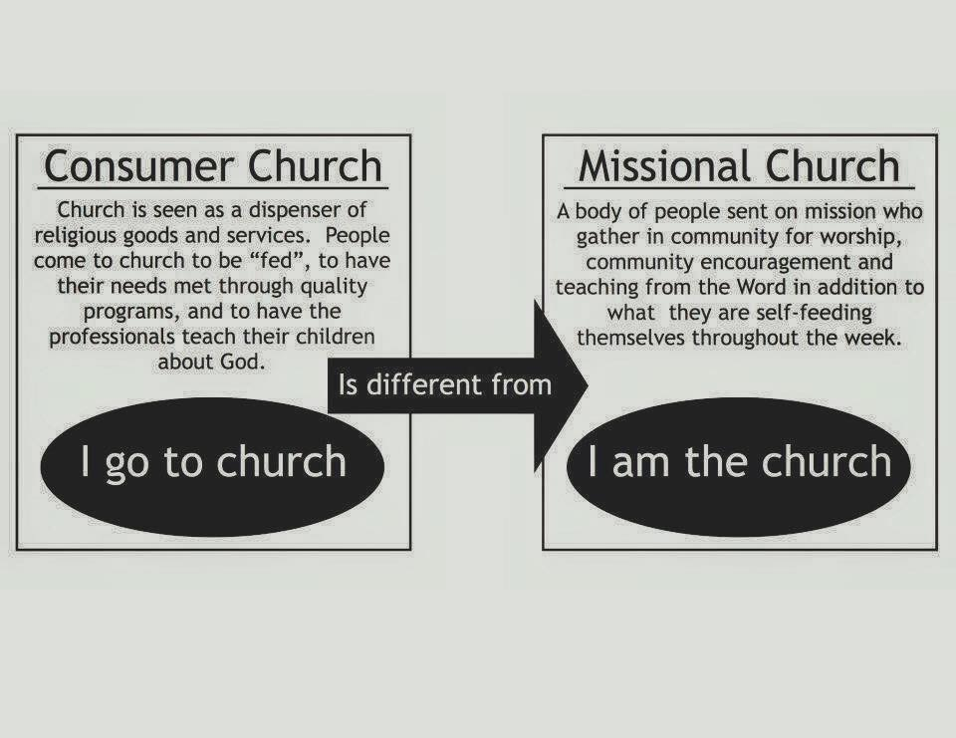

Welcome to the

Parish of St. John
The Evangelist
Conception Bay South, Newfoundland
www.stjohntheevangelistnl.com
Facebook: SJTE Topsail (please like and share the page)
Twitter: @StJohnEvang
March 17, 2019

The Bulletin is given to the Glory of God
and in Loving Memory of:

Fred Doherty

by

Wife, Margaret & Family

Diocesan Bishop: The Right Reverend Dr. Geoffrey Peddle
Rector: The Reverend Jolene Peters
Parish Deacon: The Reverend Lisa Cox
Organist/Choir Director: Stephanie Gavell
Parish Wardens: Sharon Smith and Rex Hillier
Office Administrator: Madonna Scott
Parish Sexton: Leonard Peach

Dear Friends,
A warm welcome to our services this morning. I am thankful for the attendance and support at our Annual Congregational Meeting held last Sunday afternoon. It was a wonderful meeting and a time for us to reflect upon the past year and look forward to the year ahead.
As a result of our meeting, we have a full vestry for 2019, along with a Senior Leadership team and a Parish Mission team. These were appointed by myself. Please see the full list of members inside the bulletin. I ask that you would keep these individuals in your prayers. They will be officially installed in their offices on Sunday, April 7th.
Every Blessing,

Reverend Jolene

Anglican Cycle of Prayer
PRAY for: The Church of England

Tri-Diocesan Intercessions

Cathedral Parish of St. John the Evangelist, Corner Brook

Dean and Rector- The Rev. Catherine Short

Hospital Chaplains

The Rev. Edward Keeping, St. John’s

The Rev. Canon IIiffe Sheppard, Part-time, St. John’s

The Rev. Canon David Russell, Corner Brook

The Rev. Joan Antle, Grand Falls/Windsor

The Rev. Sheila Scevior, Clarenville

The Faith Community of Saint Luke’s and Anglican Homes

The Rev. Christopher Fowler

Sick List: Ralph, Roy, Don, Nathan, Logan

The sick
If you know someone that is sick and would like to be placed on the sick list, contact the Parish Office at 834-2336 or by emailing sjtetopsail@nfld.net Please ensure that you have their permission for their name to be printed in the bulletin before calling the office. Please let us know when they are well enough to be removed from our prayer list.

8:30 a.m. Service - (BCP) Page 67
The First Reading: Genesis 15:1–12, 17–18
Psalm: 27; Refrain: The Lord is my light and my salvation.

The Holy Gospel: Luke 13:31–35

10:30 a.m. Service – See Handout
The First Reading: Genesis 15:1–12, 17–18
Psalm: 27; Refrain: The Lord is my light and my salvation.
The Epistle: Philippians 3:17—4.1
The Holy Gospel: Luke 13:31–35

Collect of the Day
Let us pray for grace to keep Lent faithfully, Hope beyond all human hope, you promise Abraham and Sarah descendants as numerous as the stars. You promise light and salvation in the midst of darkness and despair, and redemption to a world that will not listen. Gather us in tenderness and open our ears to your word, so that we may live faithfully and confidently in your promises. We ask this in the name of Jesus Christ. Amen.

Prayer over the Gifts
God of wisdom, may the light of the eternal Word, our Lord and Saviour
Jesus Christ, guide us to your glory. We ask this in his name. Amen.

Prayer after Communion
Creator of heaven and earth, we thank you for these holy mysteries,
which bring us now a share in the life to come, through Jesus Christ
our Lord. Amen.

Hymns
Processional: 440 HB Children: 713 HB Gradual: 126 HB Offertory: 41 HB (Request by Donald Sparkes) Communion: 231 & 233 HB Recessional: 589 HB

Hymn Request - March 24th - I Feel the Winds of God Today - requested by Marlene Coffin

Vestry 2019

Rector's Warden - Sharon Smith (Appointed)
People's Warden- Randy Sparkes (Elected)
Treasurer- Philip Gavell (Appointed)

Elected Members at AGM
Glenda Tapp Ashton- Synod Delegate
Dianne Hillier
John Hillier
Tracey Carter

Returning Members of Vestry
Betty Hiscock- Synod Delegate
Lorne Bugden
Alex Bugden- Youth Representative/Synod Delegate
David Morris
Iain Hollett
Lisa Coles

Senior Leadership Team (Reverend Jolene's Appointments)
Sharon Smith Stephanie Gavell
Randy Sparkes Reverend Lisa Cox
Ken Carter

Parish Mission Team (Reverend Jolene's Appointments)
David Glynn Susan Bonnell
Leanne Squire Scott Churchill
Megan Coles Michael Gregory

Social Media Officer/Photographer (Reverend Jolene's Appointment)
Shauna Wells
Michelle Sparkes

Anglican Life Representative (Reverend Jolene's Appointment)
Louise Smith

Primates World Relief and Development Fund Representative (Reverend Jolene's Appointment)
Maxine Reccord-Pinhorn

Sidespersons | Sound | Counting | Readers
Team 2  Lori C. | Jim S.  Topsail | Bruce M. | Team 10  Ros S.
Sunday Duties for Sunday, March 24, 2019

In keeping with the holidays set by the Diocesan Synod of Eastern NL, the Parish Office will be closed on Monday, March 18th

Parish Budget for 2019 – $260,642.00

Amount needed for Regular Sunday Givings
(i.e. Envelopes & PAD) Yearly - $130,000.00

Amt needed per month | Amt received in Feb.2019 | Difference +/- | Total Y-T-D
$10,834.00 | $8,825.50 | - $2,008.50 | - $3,633.95

Thank you!
We would like to thank Mrs. Elsie Rose for kindly donating a vacuum cleaner to the church. It is much appreciated!

CBS Food Bank
For the remaining three Sundays of March, we are asking for following 2 items to support our local food bank: Crackers & Sweet Biscuits.

Moms and Tots

Will meet Tuesday, March 19th @ 10:00 a.m. Hope to see you there!

Advance Notice

On Saturday, April 6th ACW will be hosting a Lasagna Supper as parish fundraiser. More details to follow.
Mid-Week Lenten Service
Join us Wednesday, March 20th at 7:00 p.m. for our Lenten Series “Cross Purposes”. This week’s service is entitled “Cross Road”.

Clergy on the Floor Lenten Campaign
Clergy members will be giving up the comfort of their homes and beds to sleep on the pews and floors of the Anglican Cathedral of St. John the Baptist on April 26th. This campaign aims to raise awareness and $10,000.00 to support the work of Home Again Furniture Bank. Home Again works toward ending furniture poverty by collecting and redistributing gently used furniture. Each week, Home Again's volunteer teams deliver beds, linins, dining room sets and sofas to individuals and families who had been sleeping, eating and studying from their floors. In seeking sponsorship to spend a night on the Cathedral floor, participating clergy are enabling others to receive the furniture and housewares they need to live with comfort and dignity. You can help by sponsoring Reverend Jolene to participate in Clergy on the Floor. Specially marked envelopes can be found at the back of the church throughout the Lenten period or you can donate directly through CanadaHelps: https://bit.ly/2k2FX4n

Newsletter
Did you know that we distribute a monthly e-newsletter? If you would like to receive this newsletter and other documents that Reverend Jolene sends out from time to time please email jolenepeters1@gmail.com to subscribe.

NO BAKE CAKE SALE
During the month of March, our ACW is holding a NO BAKE CAKE SALE. No baking to do, no recipe needed! A donation, large or small, placed in the envelope provided will be greatly appreciated. The envelope can then be placed with the offerings. Thank you!

Church Envelopes/PAD
If you would like church envelopes for your weekly/monthly offerings or would like to sign up for pre-authorized debit please contact the parish office at 834-2336 or by email sjtetopsail@nfld.net. We are grateful for your contributions towards our ministries in this parish.

Hymn Request

If you would like a hymn sung during one of our services, please contact Stephanie Gavell at 834-3445 or Rev. Jolene @ jolenepeters1@gmail.com

Hearing Assist
Hearing Assist is available for those with hearing difficulties. Pick up the hearing assist apparatus, in the back of the church or ask one of the sides people for assistance.

40 Acts of Generosity

Following Jesus means being the church and the church doesn't meet, it acts! During Lent we often deny ourselves of pleasures i.e.., giving up chocolate, but in later years there is a trend to also pick something up. If this is how you're feeling then we have a treat for you! We challenge you to participate in 40 Acts of generosity. Not just monetary but also random acts of kindness for people, a call to someone who's grieving, a treat for someone just because you're thinking about them, smiling and saying hello to a stranger to help brighten their day. Maybe you've heard of a group that is fundraising and you decide to help support their cause. At the back of the church we have provided a sheet that has blocks for 40 days (Sundays are not included). Be intentional about what you do and everyday write in your generous act for that day! If all of us participated imagine the impact that it will make on our community. If you did something and it impacted your heart, maybe you would be willing to share that in church on a Sunday morning. Please join along. We would love to collect the papers On Easter Sunday (anonymous of course) and show how we made a difference in the lives of others! For more information please contact Rev. Jolene. Together let's make a difference this Lent!!!!

An Evening of Country Gospel
Parish of the Ascension, Smallwood Drive, Mt. Pearl, will be hosting An Evening Of Country Gospel Music on March 30, 2019 at 7:00 p.m. featuring the singing group The Secrets, Parish of the Ascension Church Choir and Emma Bursey. Tickets are available at the Ascension Church office - 368-5693 or on-line at thesecrets.ca. Cost per ticket is $20 and the event starts at 7 p.m.

