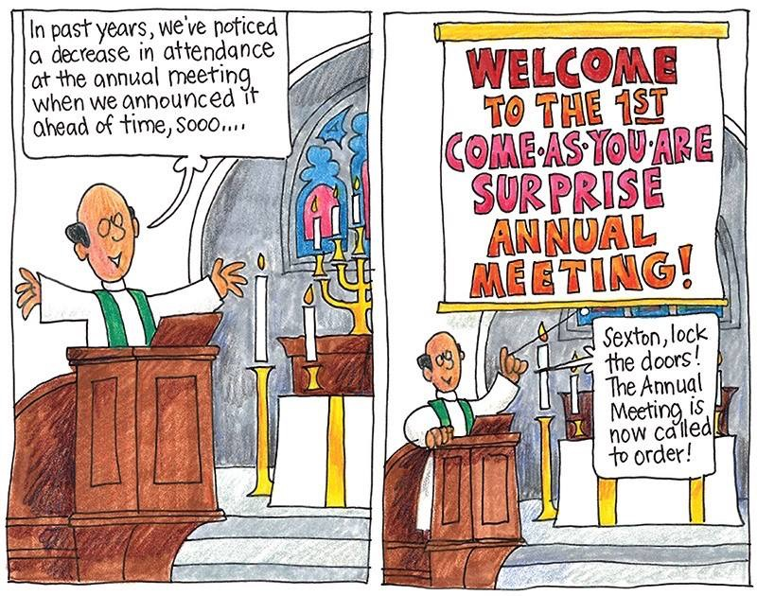

Welcome to the

Parish of St. John
The Evangelist
Conception Bay South, Newfoundland
www.stjohntheevangelistnl.com
Facebook: SJTE Topsail (please like and share the page)
Twitter: @StJohnEvang
March 10, 2019

The Bulletin is given to the Glory of God
and in Loving Memory of:
Louis Walters

by
Maud & Family

Diocesan Bishop: The Right Reverend Dr. Geoffrey Peddle
Rector: The Reverend Jolene Peters
Parish Deacon: The Reverend Lisa Cox
Organist/Choir Director: Stephanie Gavell
Parish Wardens: Sharon Smith and Rex Hillier
Office Administrator: Madonna Scott
Parish Sexton: Leonard Peach

Dear Friends,
I extend a warm welcome to you today. At 10:30 a.m. we celebrate the sacrament of Baptism and welcome Nora Kate Hynes, Daughter of Mark and Nicole Hynes into our parish family. Please introduce yourself to Mark and Nicole this morning and keep sweet Nora in your prayers as her faith journey begins.
At 12:00pm today we hold our annual congregational meeting and I invite you to join us as we reflect on 2018, elect our new members of vestry for 2019 and look ahead to the future and what lays in store for us.

I offer this prayer:

Disturb us, Lord, when we are too well pleased with ourselves,
When our dreams have come true
Because we have dreamed too little,
When we arrived safely
Because we sailed too close to the shore.
Disturb us, Lord, when
With the abundance of things we possess
We have lost our thirst
For the waters of life;
Having fallen in love with life,
We have ceased to dream of eternity
And in our efforts to build a new earth,
We have allowed our vision
Of the new Heaven to dim.
Disturb us, Lord, to dare more boldly,
To venture on wider seas
Where storms will show Your mastery;
Where losing sight of land,
We shall find the stars.
We ask You to push back
The horizons of our hopes;
And to push into the future
In strength, courage, hope, and love.

Every Blessing,

Reverend Jolene
8:30 a.m. Service - (BCP) Page 67
The First Reading: Deuteronomy 26:1–11
Psalm: 91:1–2, 9–16; Refrain: He shall give his angels charge over you.

The Holy Gospel: Luke 4:1–13

10:30 a.m. Service - (BAS) Page 185 (Lent 1 & Baptism)
The First Reading: Deuteronomy 26:1–11
Psalm: 91:1–2, 9–16; Refrain: He shall give his angels charge over you.
The Epistle: Romans 10:8b–13
The Holy Gospel: Luke 4:1–13

Collect
Almighty God, whose Son fasted forty days in the wilderness, and was
tempted as we are but did not sin, give us grace to discipline ourselves
in submission to your Spirit, that as you know our weakness, so we may
know your power to save; through Jesus Christ our Lord, who lives and
reigns with you and the Holy Spirit, one God, now and for ever. Amen.

Prayer over the Gifts
God our refuge and our strength, receive all we offer you this day, and
through the death and resurrection of your Son transform us to his likeness. We ask this in his name. Amen.

Prayer after Communion
Faithful God, in this holy bread you increase our faith and hope and love.
Lead us in the path of Christ who is your Word of life. We ask this in his

name. Amen.
Hymns
Processional: 175 CP Baptism: Choir Selection Children: See Below Offertory: 533 CP Gradual: 176 CP Communion: 531 & 66 CP
Recessional: 564 CP

Hymn Request - March 17th - Saviour, Again to Thy Dear Name We Raise - requested by Donald Sparkes
Hymn Request - March 24th - I Feel the Winds of God Today - requested by Marlene Coffin
The church is wherever God’s people are praising,
Singing God’s goodness for joy on this day.
The Church is wherever disciples of Jesus
remember his story and walk in his way.

The church is wherever God’s people are helping,
Caring for neighbours in sickness and need.
The church is wherever God’s people are sharing
the words of the Bible in gift and in deed.
Food for Thought Project
This is the last week for this project. Books should be appropriate for ages infant to twelve. There is a book bin in the Church Porch where books can be dropped off by Thursday, March 14th. Thank you for supporting this outreach project.

Clergy on the Floor Lenten Campaign
Sidespersons | Sound | Counting | Readers
Team 10  Rex H. | Jim S.  Manuels | Jim S. | Team 10  Ron S.
Clergy members will be giving up the comfort of their homes and beds to sleep on the pews and floors of the Anglican Cathedral of St. John the Baptist on April 26th. This campaign aims to raise awareness and $10,000.00 to support the work of Home Again Furniture Bank. Home Again works toward ending furniture poverty by collecting and redistributing gently used furniture. Each week, Home Again's volunteer teams deliver beds, linins, dining room sets and sofas to individuals and families who had been sleeping, eating and studying from their floors. In seeking sponsorship to spend a night on the Cathedral floor, participating clergy are enabling others to receive the furniture and housewares they need to live with comfort and dignity. You can help by sponsoring Reverend Jolene to participate in Clergy on the Floor. Specially marked envelopes can be found at the back of the church throughout the Lenten period or you can donate directly through CanadaHelps: https://bit.ly/2k2FX4n

Newsletter
Did you know that we distribute a monthly e-newsletter? If you would like to receive this newsletter and other documents that Reverend Jolene sends out from time to time please email jolenepeters1@gmail.com to subscribe.

NO BAKE CAKE SALE
During the month of March, our ACW is holding a NO BAKE CAKE SALE. No baking to do, no recipe needed! A donation, large or small, placed in the envelope provided will be greatly appreciated. The envelope can then be placed with the offerings. Thank you!

ACW of All Saints Parish, Foxtrap….
…are hosting a Paddy’s Day Brunch on March 16th. from 10am – 1 pm downstairs in the parish hall. Cost will be $12.00 [adults] and $6.00 [children] For more information, call Barb 834-4795.

Anglican Cycle of Prayer
PRAY for: The Province de L'Eglise Anglicane Du Congo

Tri-Diocesan Intercessions

Parish of Catalina

Rector- The Rev. Neal Buffett

Parish of St. John the Baptist

Rector - The Rev. Roger Whelan

Sick List: Ralph, Roy, Don, Nathan, Logan

The sick
If you know someone that is sick and would like to be placed on the sick list, contact the Parish Office at 834-2336 or by emailing sjtetopsail@nfld.net Please ensure that you have their permission for their name to be printed in the bulletin before calling the office. Please let us know when they are well enough to be removed from our prayer list.

Sunday Duties for Sunday, March 17, 2019

Parish Budget for 2019 – $260,642.00

Amount needed for Regular Sunday Givings
(i.e. Envelopes & PAD) Yearly - $130,000.00

Amt needed per month | Amt received in Feb.2019 | Difference +/- | Total Y-T-D
$10,834.00 | $8,825.50 | - $2,008.50 | - $3,633.95

Church Envelopes/PAD
If you would like church envelopes for your weekly/monthly offerings or would like to sign up for pre-authorized debit please contact the parish office at 834-2336 or by email sjtetopsail@nfld.net. We are grateful for your contributions towards our ministries in this parish.

ACW

There will be a meeting of ACW on Tuesday, March 12th @ 10:30 a.m. All ladies are welcome.

Hymn Request

If you would like a hymn sung during one of our services, please contact Stephanie Gavell at 834-3445 or Rev. Jolene @ jolenepeters1@gmail.com

Hearing Assist
Hearing Assist is available for those with hearing difficulties. Pick up the hearing assist apparatus, in the back of the church or ask one of the sides people for assistance.

Diocese Appointment
In his most recent letter to the Diocese, Bishop Geoff has appointed Rev. Jolene as Mission Dean for the two newly formed missions of Conception Bay South and the Northeast Avalon. This appointment is an addition to her duties as Rector of St. John the Evangelist as is effective for the next two years with the option of an additional year. Rev. Jolene joins the Rev’ds Jonathan Rowe, Christine Lynch, Eli Evans as members of an extended Cathedral Chapter. They will be formerly installed in their offices on Sunday, April 7th @ 7:00 p.m. in the Cathedral.

Thank you
Thank you to all who helped with the Pancake Supper! It was a wonderful evening and great success. Thank you to the cooks, the servers, those who set up and cleaned up, or helped in any way and especially to all those who purchased a ticket and attended. A job well done by everyone involved.

Mid-Week Lenten Service
Join us Wednesday, March 13th at 7:00 p.m. for our Lenten Series “Cross Purposes”. This week’s service entitled “Cross Out”.

Ukrainian Egg Workshop at The Cathedral: Pysanky is the Ukrainian word for Easter Eggs—those beautiful and intricately decorated eggs that are so famous at this time of year. The word “pysanka” actually means “to write” and the art of writing on an egg with beeswax is part of the mysterious process of this artform. There are many legends associated with Ukrainian egg-making and some of these will also be shared. Jan Buley is offering a 3-hour workshop on Saturday March 30th from 1 to 4pm at the Cathedral. All materials are included and proceeds from the workshop will go towards books and puppets for the children’s area. Cost for adults $20 (16 years of age and older), and children aged 8-15 years $10. Space is limited! Please contact Archdeacon Roger Whalen for information and to register: whalen_roger@hotmail.com.

40 Acts of Generosity

Following Jesus means being the church and the church doesn't meet, it acts! During Lent we often deny ourselves of pleasures i.e.., giving up chocolate, but in later years there is a trend to also pick something up. If this is how you're feeling then we have a treat for you! We challenge you to participate in 40 Acts of generosity. Not just monetary but also random acts of kindness for people, a call to someone who's grieving, a treat for someone just because you're thinking about them, smiling and saying hello to a stranger to help brighten their day. Maybe you've heard of a group that is fundraising and you decide to help support their cause. At the back of the church we have provided a sheet that has blocks for 40 days (Sundays are not included). Be intentional about what you do and everyday write in your generous act for that day! If all of us participated imagine the impact that it will make on our community. If you did something and it impacted your heart, maybe you would be willing to share that in church on a Sunday morning. Please join along. We would love to collect the papers On Easter Sunday (anonymous of course) and show how we made a difference in the lives of others! For more information please contact Rev. Jolene . Together let's make a difference this Lent!!!!

