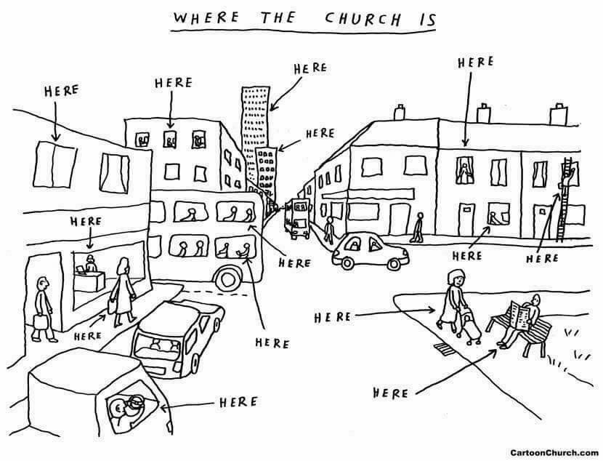

Welcome to the

Parish of St. John
The Evangelist
Conception Bay South, Newfoundland
www.stjohntheevangelistnl.com
Facebook: SJTE Topsail (please like and share the page)
Twitter: @StJohnEvang
March 3, 2019

The Bulletin is given to the Glory of God
and in Loving Memory of:
Baxter Rose
Remembering his death March 2nd, 2013

by
Wife Elsie, Sons, John & Steven & their Families

Diocesan Bishop: The Right Reverend Dr. Geoffrey Peddle
Rector: The Reverend Jolene Peters
Parish Deacon: The Reverend Lisa Cox
Organist/Choir Director: Stephanie Gavell
Parish Wardens: Sharon Smith and Rex Hillier
Office Administrator: Madonna Scott
Parish Sexton: Leonard Peach

Dear Friends,
I extend a warm welcome to you today. Today, at 10:30am we have our family worship service. This service gives our young people the opportunity to participate fully and gain a deeper understanding into the life of the church. We pray they will continue to be a part of as they grow. Let us show our young people encouragement, support and hold them in prayer as they find with us a place they can belong. If you are able to stay please join us today for a time of fellowship after our service downstairs in our hall. If you don't know someone then make an attempt to get to know them better today. If you are visiting with us today, please make yourself known and we pray that your time with us will be spirit filled.
Every Blessing,
Reverend Jolene

Anglican Cycle of Prayer
PRAY for: The Iglesia Anglicana de Chile

Tri-Diocesan Intercessions
Parish of

Rector- The Rev. James Spencer

Parish by the Sea

Priest-in-Charge - The Rev. Elsie Rose

Parish of Carbonear
Rector- The Rev. Irene Sutton

Sick List: Ralph, Roy, Don, Nathan, Logan

The sick
If you know someone that is sick and would like to be placed on the sick list, contact the Parish Office at 834-2336 or by emailing sjtetopsail@nfld.net Please ensure that you have their permission for their name to be printed in the bulletin before calling the office. Please let us know when they are well enough to be removed from our prayer list.

Sunday Duties for Sunday, March 10, 2019

Sidespersons | Sound | Counting | Readers
Team 9  Frank P. | James S.  Topsail | Philip G. | Team 9  Louise S.

8:30 a.m. Service - (BCP) Page 67
The First Reading: Exodus 34:29–35
Psalm: 99
Refrain: The Lord our God is the Holy One.

The Holy Gospel: Luke 9:28–36 (37–43a)

Collect
Almighty God, on the holy mount you revealed to chosen witnesses
your well-beloved son, wonderfully transfigured: mercifully deliver us
from the darkness of this world, and change us into his likeness from glory to glory; through Jesus Christ our Lord who lives and reigns with you and the Holy Spirit, one God, now and for ever. Amen.

Prayer over the Gifts
Holy God, receive all we offer you this day, and bring us to that radiant
glory which we see in the transfigured face of Jesus our Lord. Amen.

Prayer after Communion
Holy God, we see your glory in the face of Jesus Christ. May we who are
partakers of his table reflect his life in word and deed, that all the world may know his power to change and save. We ask this in his name. Amen.
10:30 a.m. Service – Family Service
See Handout

Hymns
Processional:61 B Offertory: 90 B
Gradual: 64 B Recessional: 115 B

Hymn Request

If you would like a hymn sung during one of our services, please contact Stephanie Gavell at 834-3445 or Rev. Jolene @ jolenepeters1@gmail.com

Hearing Assist
Hearing Assist is available for those with hearing difficulties. Pick up the hearing assist apparatus, in the back of the church or ask one of the sides people for assistance.

Food for Thought Project
The project will run from February 14th until March 14th. Books should be appropriate for ages infant to twelve. There will be a book bin placed in the Church Porch where families can drop off books on Sunday mornings.

MOMS AND TOTS
This program is for ages 0-4 years along with parents, grandparents, or guardians. Please join us this Tuesday March 5 from 10-11:30am for Pancake Day! We will be serving pancakes and having some play time as well. We look forward to seeing you there!

Clergy on the Floor Lenten Campaign
Clergy members will be giving up the comfort of their homes and beds to sleep on the pews and floors of the Anglican Cathedral of St. John the Baptist on April 26th. This campaign aims to raise awareness and $10,000.00 to support the work of Home Again Furniture Bank. Home Again works toward ending furniture poverty by collecting and redistributing gently used furniture. Each week, Home Again's volunteer teams deliver beds, linins, dining room sets and sofas to individuals and families who had been sleeping, eating and studying from their floors. In seeking sponsorship to spend a night on the Cathedral floor, participating clergy are enabling others to receive the furniture and housewares they need to live with comfort and dignity. You can help by sponsoring Reverend Jolene to participate in Clergy on the Floor. Specially marked envelopes can be found at the back of the church throughout the Lenten period or you can donate directly through CanadaHelps: https://bit.ly/2k2FX4n

Newsletter
Did you know that we distribute a monthly e-newsletter? If you would like to receive this newsletter and other documents that Reverend Jolene sends out from time to time please email jolenepeters1@gmail.com to subscribe.
The flowers on the Altar today is given to the Glory of God and in Loving memory of:
Baxter Rose
by
Wife, Elsie and Sons, John & Steven
and their families

****

Parish Budget for 2019 – $260,642.00

Amount needed for Regular Sunday Givings
(i.e. Envelopes & PAD) - $130,000.00

Amt needed per month | Amt received in Feb.2019 | Difference +/- | Total Y-T-D
$10,834.00 | $8,825.50 | - $2,008.50 | - $3,633.95

Annual Meeting
Our Annual Congregational Meeting takes place next Sunday March 10 at 12pm, following our 10:30am service. We will serve tea, coffee and sandwiches. Please make every attempt to come to this very important meeting.

Vacuum Cleaner Needed!

We are looking for a vacuum cleaner for use in the church. If you have one that you currently are not using, we would greatly appreciate it!

Ash Wednesday
Our Ash Wednesday service will take place on Wednesday March 6th at 7:00pm

Diocesan Appointments
As per the motions passed at our Diocesan Synod in November Bishop Peddle has announced the appointments of four mission deans and eight mission areas for the Archeaconary of the Avalon and the Archdeaconry of Trinity/Conception/Placentia as listed below. The Mission Dean for Conception Bay South and the Northeast Avalon will be The Reverend Jolene Peters. The Mission Dean for Mount Pearl/Goulds and St. John’s will be The Reverend Jonathan Rowe. The Mission Dean for Conception Bay North Central and Conception Bay North will be The Reverend Christine Lynch. The Mission Dean for Trinity Bay and the Isthmus will be The Reverend Eli Evans. The formal installation of the Cathedral Chapter and Mission Deans will take place on the evening of Sunday, April 7, at 7 p.m. at the Cathedral of St John the Baptist. The date of the first meeting of the Chapter will be Monday, April 8 and Tuesday, April 9. There are copies of Bishop Peddle's letter in the back of the church, as well as the Diocesan Facebook page and website.
Vestry Membership
This year we are looking for the following positions for our Vestry which is the main operating board of our parish. We are searching for People's Warden, Treasurer, one synod delegate and three vestry members. If you are interested in any of these positions please speak with one of our selection committee members (Rex Hillier, Dave Morris, Sharon Smith or Reverend Jolene) for more details.

Shrove Tuesday
The ACW will hold their Annual Baked Beans, Sausages and Pancake supper on Shrove Tuesday, March 05 at 6 p.m. in the Parish Hall. Tickets are $12.00 for adults and $6.00 for children under 12 years and will be available Sunday, February 24th. Please contact Louise at 834-7385 or Shirley at 368-9504 to book your tickets.

Church Envelopes/PAD
If you would like church envelopes for your weekly/monthly offerings or would like to sign up for pre-authorized debit please contact the parish office at 834-2336 or by email sjtetopsail@nfld.net. We are grateful for your contributions towards our ministries in this parish.
GPS 2019- God’s Positioning System: Seeking God’s Direction in Every Day Life and in Life Every Day!
This Diocesan Youth Conference is for youth from grade 7 and up, to come together to discover how faith is an important part of everyday life. Through guest speakers, outreach initiatives and other activities, youth have an opportunity to explore their faith with other young people from all across the Diocese. It will be held at the Lavrock Camp and Conference Center with all accommodations and food provided for free! The deadline for registration is March 15. Registration forms are available from your rector. If you have any questions please email the Reverend Canon Amanda Taylor at revamandataylor@gmail.com. We hope to see you there!

40 Acts of Generosity

Following Jesus means being the church and the church doesn't meet, it acts! During Lent we often deny ourselves of pleasures i.e.., giving up chocolate, but in later years there is a trend to also pick something up. If this is how you're feeling then we have a treat for you! We challenge you to participate in 40 Acts of generosity. Not just monetary but also random acts of kindness for people, a call to someone who's grieving, a treat for someone just because you're thinking about them, smiling and saying hello to a stranger to help brighten their day. Maybe you've heard of a group that is fundraising and you decide to help support their cause. At the back of the church we have provided a sheet that has blocks for 40 days (Sundays are not included). Be intentional about what you do and everyday write in your generous act for that day! If all of us participated imagine the impact that it will make on our community. If you did something and it impacted your heart, maybe you would be willing to share that in church on a Sunday morning. Please join along. We would love to collect the papers On Easter Sunday (anonymous of course) and show how we made a difference in the lives of others! For more information please contact Rev. Jolene Together let's make a difference this Lent!!!!

NO BAKE CAKE SALE
During the month of March, our ACW is holding a NO BAKE CAKE SALE. No baking to do, no recipe needed! A donation, large or small, placed in the envelope provided will be greatly appreciated. The envelope can then be placed with the offerings. Thank you!

